Accredited by NAAC ‘B’ Grade | S.G.V.V.T’s  SRI GAVISIDDESHWAR  Arts Science and Commerce College, Koppal  (Affiliated By Vijayanagara Sri Krishnadevaraya University, Ballari)

DEPARTMENT OF PHYSICAL EDUCATION

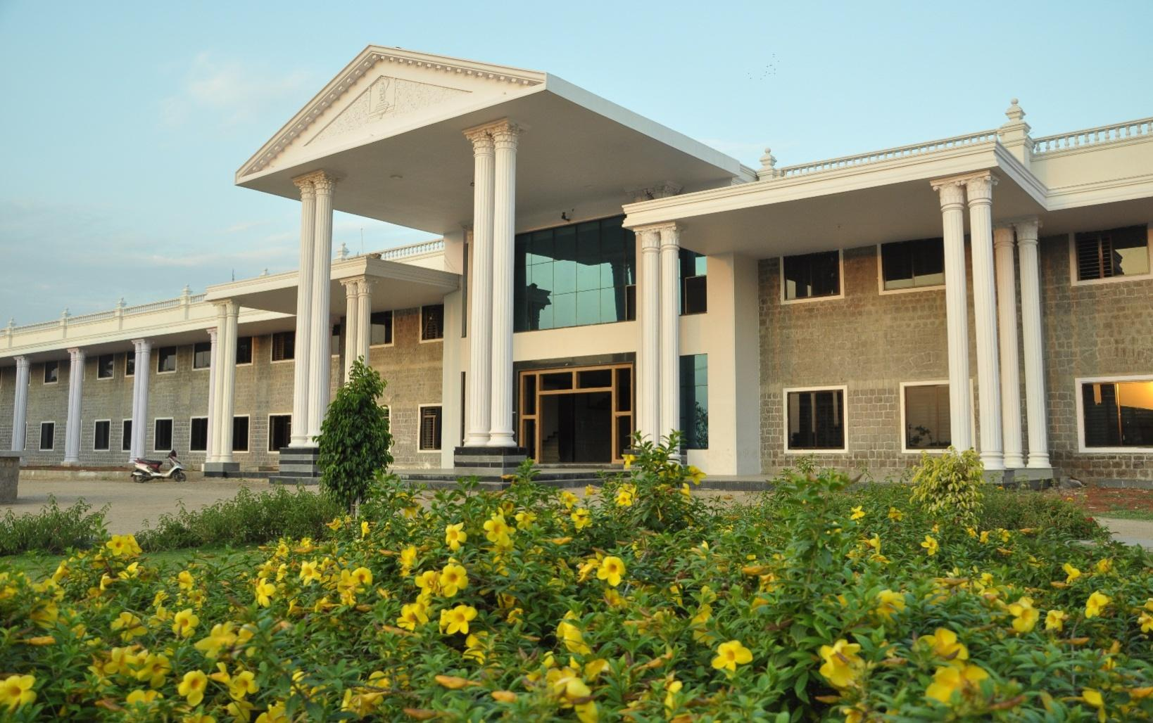

ANNUAL REPORT 2018-19

S.G.V.V. Trust’s,
Sri Gavisiddeshwar Arts, Science and Commerce College, Gavimath Campus, Koppal-583231

DEPARTMENT OF PHYSICAL EDUCATION

ANNUAL REPORT 2018-19

Submitted By:
Vinod C.Mudibasanagoudar
Physical Education Director

Submitted To:
Prof. M. S. Dadmi
Principal
S. G. College Koppal

Contents

- About the Department
- Annual Report
- Prize Winners - Athletics Men
- Prize Winners - Athletics Women
- Group Games
- Indoor Games – Men
- Indoor Games – Women
- Photo Gallery

- About the Department:

I am here to place a brief report of physical education department of our college. This is to bring it to your kind personal that our instructions besides achieving academic excellence due importance has also been given to sports activities. Until the establishment of the physical education department of sports activities were conducted for the students by teaching staff. However to provide systematic education to the students. In the year 1979 a full pledged department of the physical education was established and also appointed a part-time physical director. There after sports activities became part and partial of academic activities.
We are proud to mention here that so for our department has produced more than 191 University Representatives (University Blues) in various in Team games. Sir, we are having our representation in Athletics, Kho-Kho, Volleyball, Cross Country, Wrestling, Judo, Kabaddi, Chess, Handball, Pencak Silat and Power Lifting Weight Lifting in the University teams. Several times our college University Representatives have led the University team effectively participated in Inter-University tournaments held in different states.
Further, to involve more numbers of students in sports, activities, Intra-mural sports activities are conducted every year. Generally in the month of January and February. Annual Sports day is organized to give away the prizes to the winners. To inspire and encourage sportsmen and to facilitate University players. Important personalities in field were invited as chief guest. To mention few Dr.Pratap Singh Tiwari, Director of Physical Education GUG, Sri AnandKatti, Ranaji Cricket player and Miss.Premalata Sureban an International Cyclist were invited as chief Guests for annual Day.
We take the pride to mention that the University has recommended our institution to organize 24th Inter Collegiate Athletic meet on 3rd 4th and 5 December 2004 for which all preparatory and necessary arrangements are going on.
We are thankful to the management of the institution who were kind enough to encourage and scope for the development of sports activities.

- Annual Report:

It is our proud to inform that, the department tried to support the students overall growth and development through organizing various events annually such as Cricket League, Kabaddi league, Volleyball league, Badminton league, Chess , Carom and Athletics at the institutional level, While various students participated in inter-collegiate tournaments and inter-University competitions. Department of Physical Education was produced more than 191 University Representatives (University Blues)from our college most important achievements for the academic year 2018-19 are as follows.

- Miss. Hanamavva Swari has participated in the Inter Collegiate Cross-Country Championship held at VSKU’S P.G. Centre Nandihalli on 4th & 5th Sept 2018. She has selected for All India Inter-university Cross Country Championship 2018-19 held at Gulbarga University (Kalburgi) on 28th Sept 2018.
- Mr. AkshayakumarHiremath has participated in the Inter Collegiate Volleyball Tournament cum Selection Trails on 18th&19thsept 2018 at VSKU Ballari. He has selected for South Zone Inter-University Volleyball Tournament and considered as University Blue.

- Mr. SomuHunagund has participated in the Inter-Collegiate Handball Tournament cum selection trails held on 28th Oct 2018 at Ballari. He has selected for South Zone Inter-University Handball Tournament 2018-19 and considered as University Blue.

- Miss. RukminiBangaligidad has bagged Silver medal in Ganda Outdoor Pencak Silat and Bronze Medal in Ganda Indoor Pencak Silat in All India Inter-University Pencak Silat Championship held at Guru Nanak University Amritsar on 19thMarch to 22nd March 2019,Prior that ,She was selected in the Inter-Collegiate Pencak Silat Championship held at Shri Anand Sing Govt. First Grade College, Hospete on 21st Feb 2019.

The Annual Sports Meet was conducted from 8th Feb to 19th Feb 2019.The cricket League has inaugurated by Dr.BasavarajPujar, Dr.Channabasava and Sri ArunkumarA.G were present on the occasion. All the teams representing each class as a team and participated in the meet.All the group games, Indoor games and Athletics has scheduled on the different days & Prize distribution at the Annual Sports Day held on 3rd April 2019the following Students won the prizes.
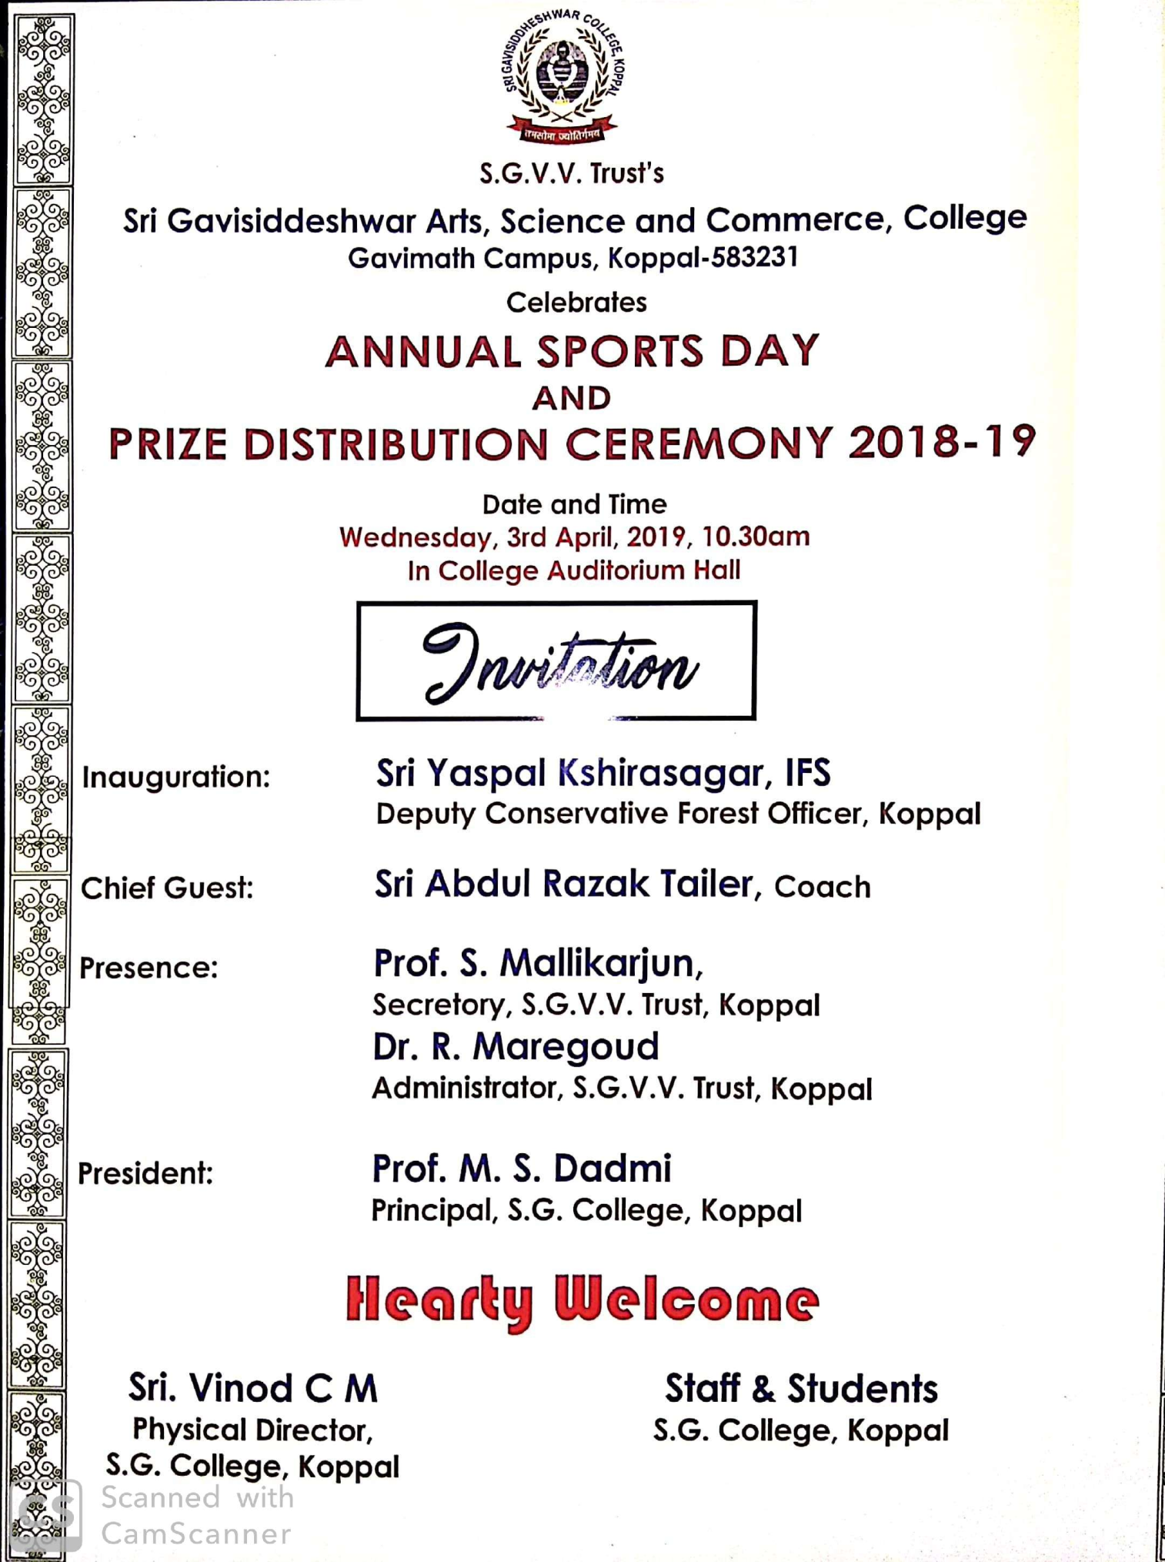

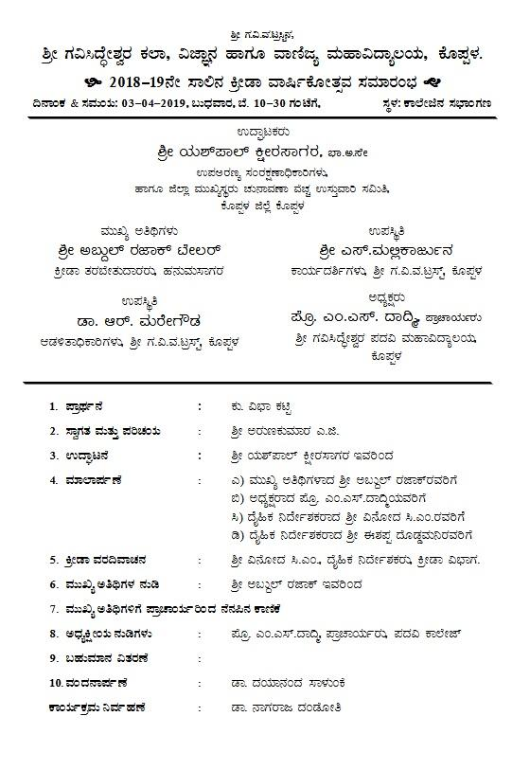

- Prize Winners - Athletics Men

Sl. No. | Name of the Student | Class | Event | Place
1 | Mahesh | B.Com I Year | 100 Mtr Running | First
2 | Ravi | B.Com I Year | 100 Mtr Running | Second
3 | Shivakumar | B.Com III Year | 100 Mtr Running | Third
4 | Homanna | BA I Year | 200 Mtr Running | First
5 | Ravi | B.Com I Year | 200 Mtr Running | Second
6 | Mahesh | B.Com I Year | 200 Mtr Running | Third
7 | Homanna | BA I Year | 400 Mtr Running | First
8 | Chandrashekhar | BA I Year | 400 Mtr Running | Second
9 | Siddalingayya | B.Com I Year | 400 Mtr Running | Third
10 | Kunteppa | BA I Year | 800 Mtr Running | First
11 | Anilkumar | B.Sc. II Year | 800 Mtr Running | Second
12 | Sayikrishna | B.Com II Year | 800 Mtr Running | Third
13 | Ganesh | B.Com II Year | 1500 Mtr Running | First
14 | Manjunath | BA II Year | 1500 Mtr Running | Second
15 | Basavaraj | B.Sc. I Year | 1500 Mtr Running | Third
16 | Anilkumar | B.Sc. II Year | Long Jump | First
17 | Homanna | BA I Year | Long Jump | Second
18 | Druva | BA II Year | Long Jump | Third
19 | Sharanappa | B.Sc. III Year | High Jump | First
20 | Druva | BA III Year | High Jump | Second
21 | Somashekhar | B.Com II Year | High Jump | Third
22 | Praveen Y.M. | B.Sc. I Year | Shot-put | First
23 | Vinay G.K. | B.Sc. I Year | Shot-put | Second
24 | Akshay K.H. | B.Sc. II Year | Shot-put | Third
25 | Praveen Y.M. | B.Sc. I Year | Discuss throw | First
26 | Ravi | B.Com I Year | Discuss throw | Second
27 | Druva K. | B.A. I Year | Discuss throw | Third
28 | Vinayak H. | B.Sc II Year | Javelin | First
29 | Shivakumar B. | B.Sc. II Year | Javelin | Second
30 | Akshay C.M. | B.Com I Year | Javelin | Third
31 | Praveen Y.M. | B.Sc. I Year | HammerThrow | First
32 | Somaraj Reddy | B.A. II Year | HammerThrow | Second
33 | Akshay C.M. | B.Com I Year | HammerThrow | Third
- Prize Winners - Athletics Woman

Sl. No. | Name of the Student | Class | Event | Place
1 | Saraswati | BA I Year | 100 Mtr Running | First
2 | HanamavvaSwari | BA I Year | 100 Mtr Running | Second
3 | Bhageerathi | B.Sc. I Year | 100 Mtr Running | Third
4 | Saraswati | BA I Year | 200 Mtr Running | First
5 | HanamavvaSwari | BA I Year | 200 Mtr Running | Second
6 | Bhageerathi | B.Sc. I Year | 200 Mtr Running | Third
7 | HanamavvaSwari | BA I Year | 400 Mtr Running | First
8 | Arpitha | BA III Year | 400 Mtr Running | Second
9 | Sarswti | BA I Year | 400 Mtr Running | Third
10 | HnamavvaSwari | BA I Year | 800 Mtr Running | First
11 | Bhageerathi | B.Sc. IYear | 800 Mtr Running | Second
12 | Swetha | BA I Year | 800 Mtr Running | Third
16 | HnamavvaSwari | BA I Year | Long Jump | First
17 | Bhageerathi | B.Sc. IYear | Long Jump | Second
18 | Siddamma | BA I Year | Long Jump | Third
19 | Arpitha | BA III Year | High Jump | First
20 | HnamavvaSwari | BA I Year | High Jump | Second
21 | Ashwini A.K. | BA III Year | High Jump | Third
22 | Ashwini A.K. | BA III Year | Shot-put | First
23 | HnamavvaSwari | BA I Year | Shot-put | Second
24 | Arpitha | BA III Year | Shot-put | Third
25 | Ashwini A.K. | BA III Year | Discuss throw | First
26 | HnamavvaSwari | BA I Year | Discuss throw | Second
27 | Arpitha | BA III Year | Discuss throw | Third
28 | Ashwini A.K. | BA III Year | Javelin | First
29 | HnamavvaSwari | BA I Year | Javelin | Second
30 | Arpitha | BA III Year | Javelin | Third

- Group Games:

Sl.No | Game | Place | Class
1 | CRICKET | I | B.Com III
1 | CRICKET | II | B.Com I
2 | VOLLEYBALL | I | B.Sc. II
2 | VOLLEYBALL | II | B.Com I
3 | KABADDI | I | B.A I
3 | KABADDI | II | B.Com I

- Indoor Games – Men:

Sl. No. | Game | Participated Students | Class | Place
1 | BADMINTON DOUBLE | Akhshay | B.Sc. II Year | First
1 | BADMINTON DOUBLE | Shankar | B.Sc. II Year | First
1 | BADMINTON DOUBLE | Ganesh | B.Com II Year | Second
1 | BADMINTON DOUBLE | Shivakumar | B.Com II Year | Second
2 | CARROM DOUBLES | Shivaraj | B.Com III Year | First
2 | CARROM DOUBLES | Dyamanna | B.Com III Year | First
2 | CARROM DOUBLES | Vinayak | B.Com II Year | Second
2 | CARROM DOUBLES | Shivakumar | B.Com II Year | Second
3 | CHESS | Amaresh | B.Sc. I Year | First
3 | CHESS | Shrinivas | B.A II Year | Second

- Indoor Games – Women:

Sl. No. | Game | Participated Students | Class | Place
1 | BADMINTON DOUBLE | Poornima | B.Sc. II | First
1 | BADMINTON DOUBLE | Dikhsha | B.Sc. II | First
1 | BADMINTON DOUBLE | Shruthi | B.A II | Second
1 | BADMINTON DOUBLE | Manisha | B.A II | Second
2 | CARROM DOUBLES | Sahana | B.Sc. II | First
2 | CARROM DOUBLES | Netra | B.Sc. II | First
2 | CARROM DOUBLES | Vinashree | B.Com II | Second
2 | CARROM DOUBLES | Amrutha | B.Com II | Second
3 | CHESS | Shwetha Kulkarni | B.Sc I | First
3 | CHESS | Vinashree | B.A II | Second

Photo Gallery

Inter Collegiate Pencak Silat Championship Cum Selection Trails
Shankar Anand Sing College G.F.G. College, Hospet

Inter Collegiate Pencak Silat Championship Cum Selection Trails
Shankar Anand Sing College G.F.G. College, Hospet

Meet our Achievers Programme

All India inter university Pencak Silat Championship Silver and Bronze medalist Ms. RukminiBangaligidad has Facilitated by Sri. M.S.Dadmi, Principal, S.G.College, Koppal

Our Achievers Our Pride
1. Ganesh Bannada, NSS CM RD Parade Commander
2. RukminiBangaligidad, All Indian Inter University Pencak Silat Championship 2018-19 Medalist.
3. VeereshEnni, NCC 2018-19 RD Parade Participant.

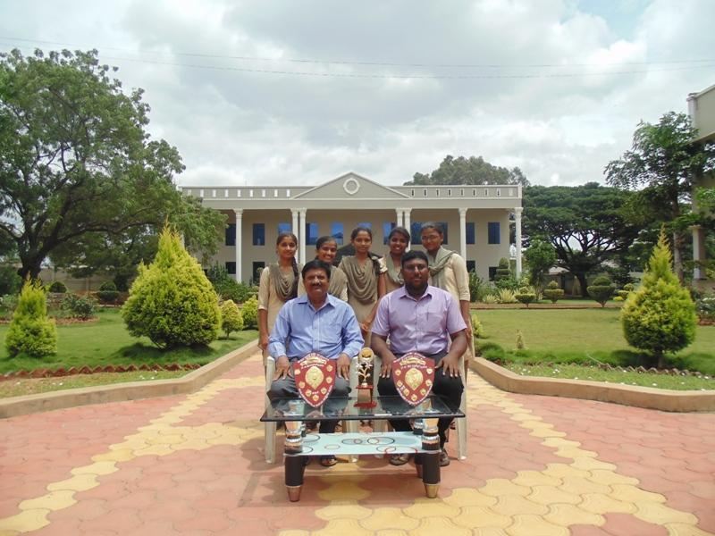

Inter-Collegiate Badminton
Women Champions 2018-19

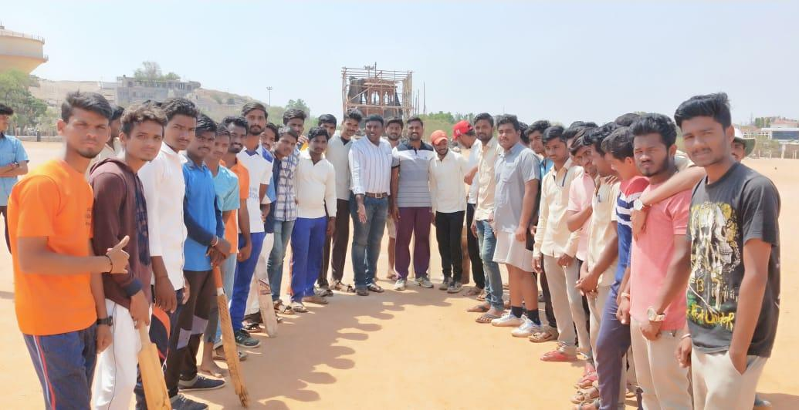

Annual Sports
2018-19

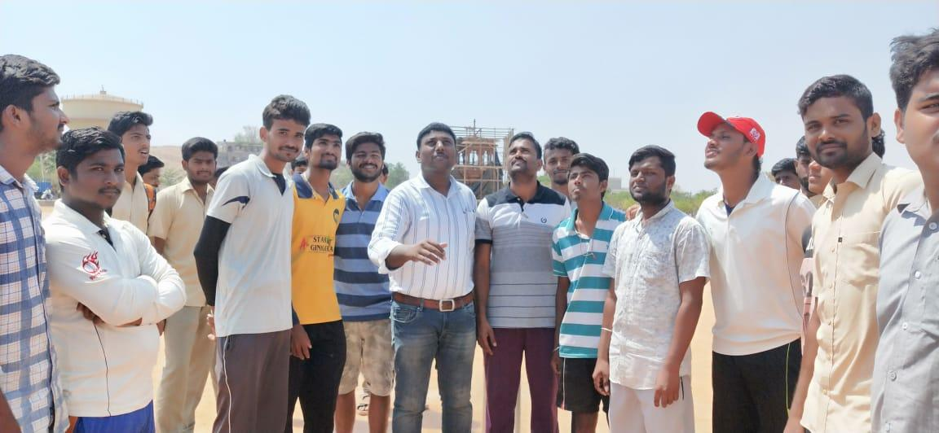

Annual Sports
During Toss

Artistic Yoga performance by Certificate in Yoga Studies Students
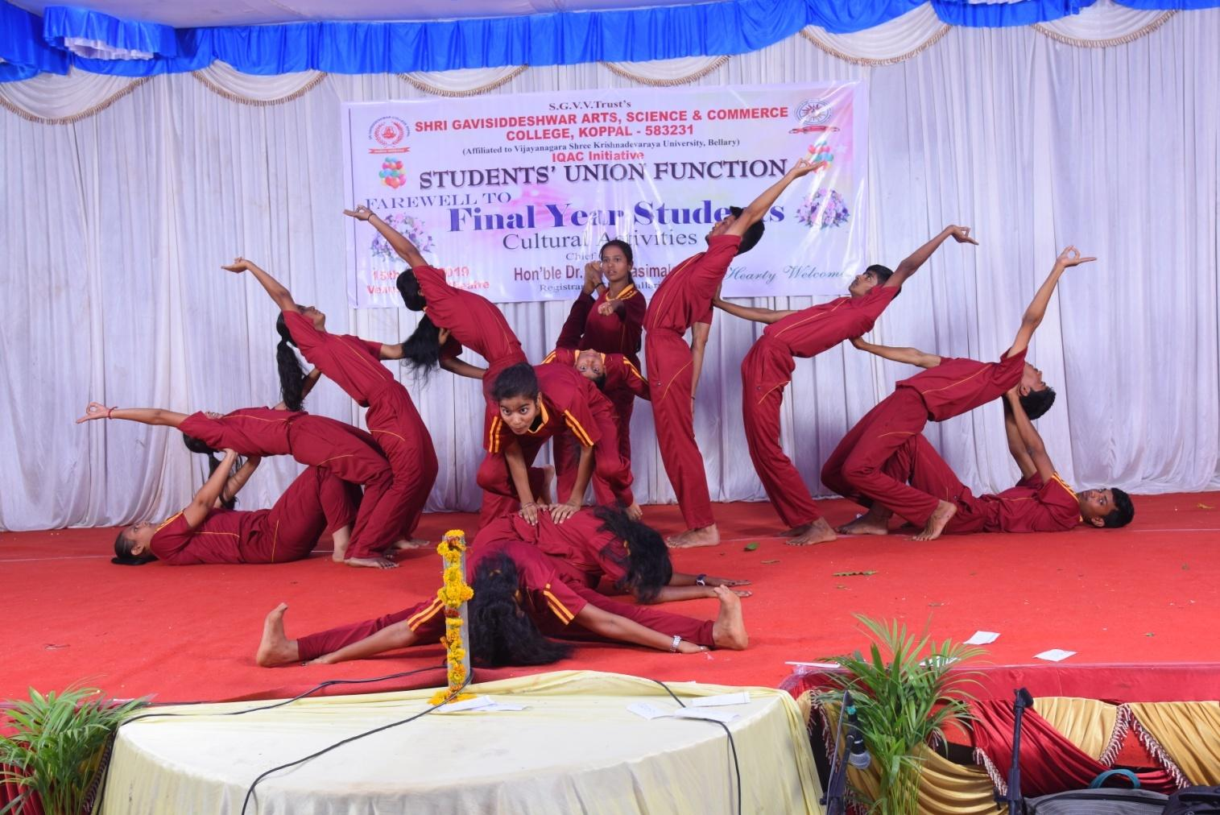

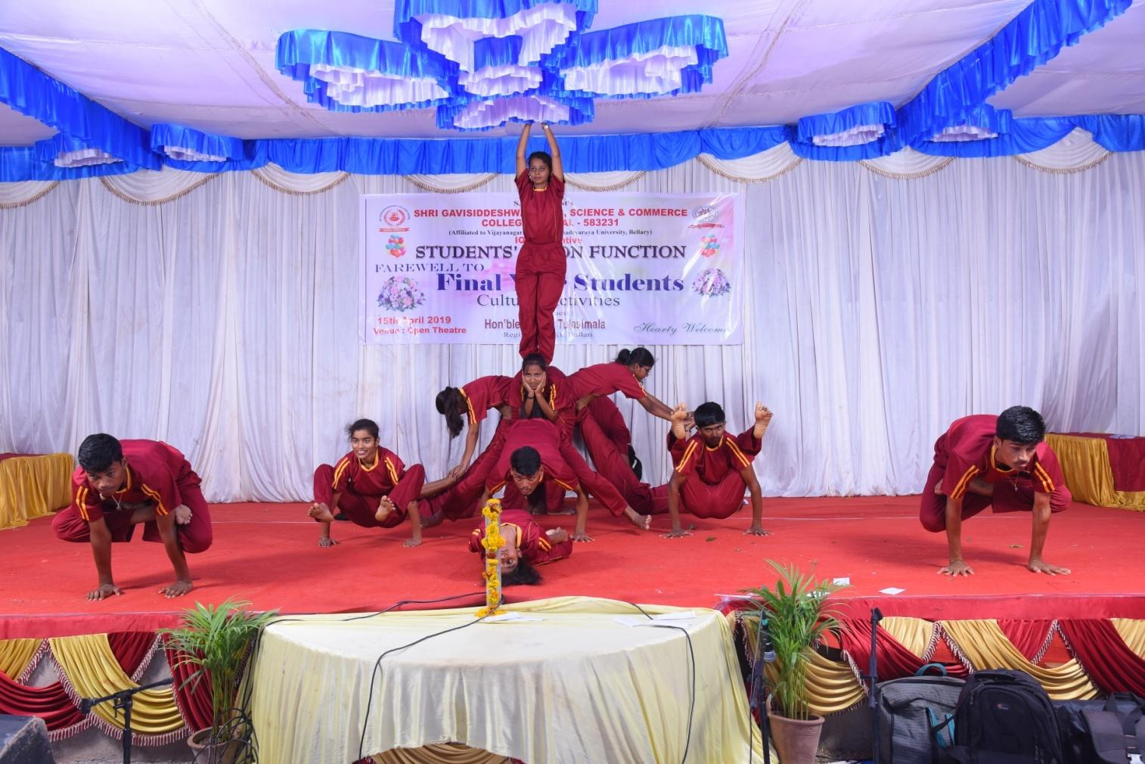

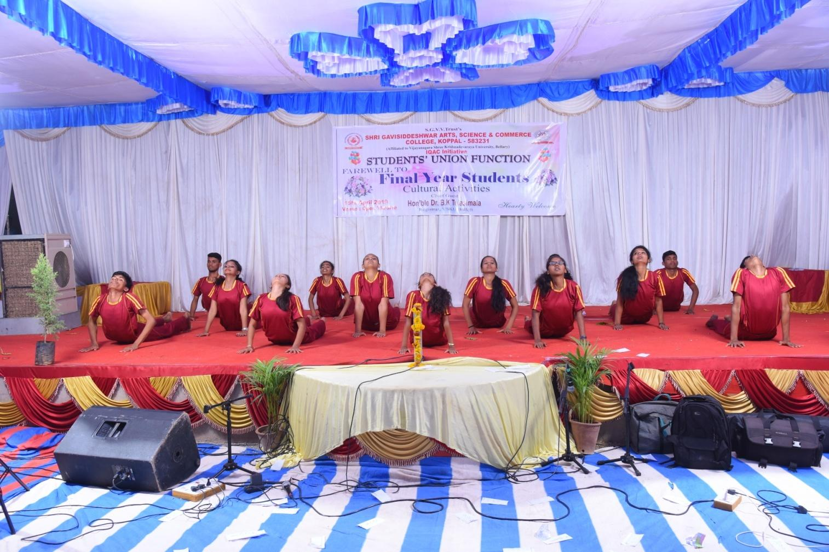

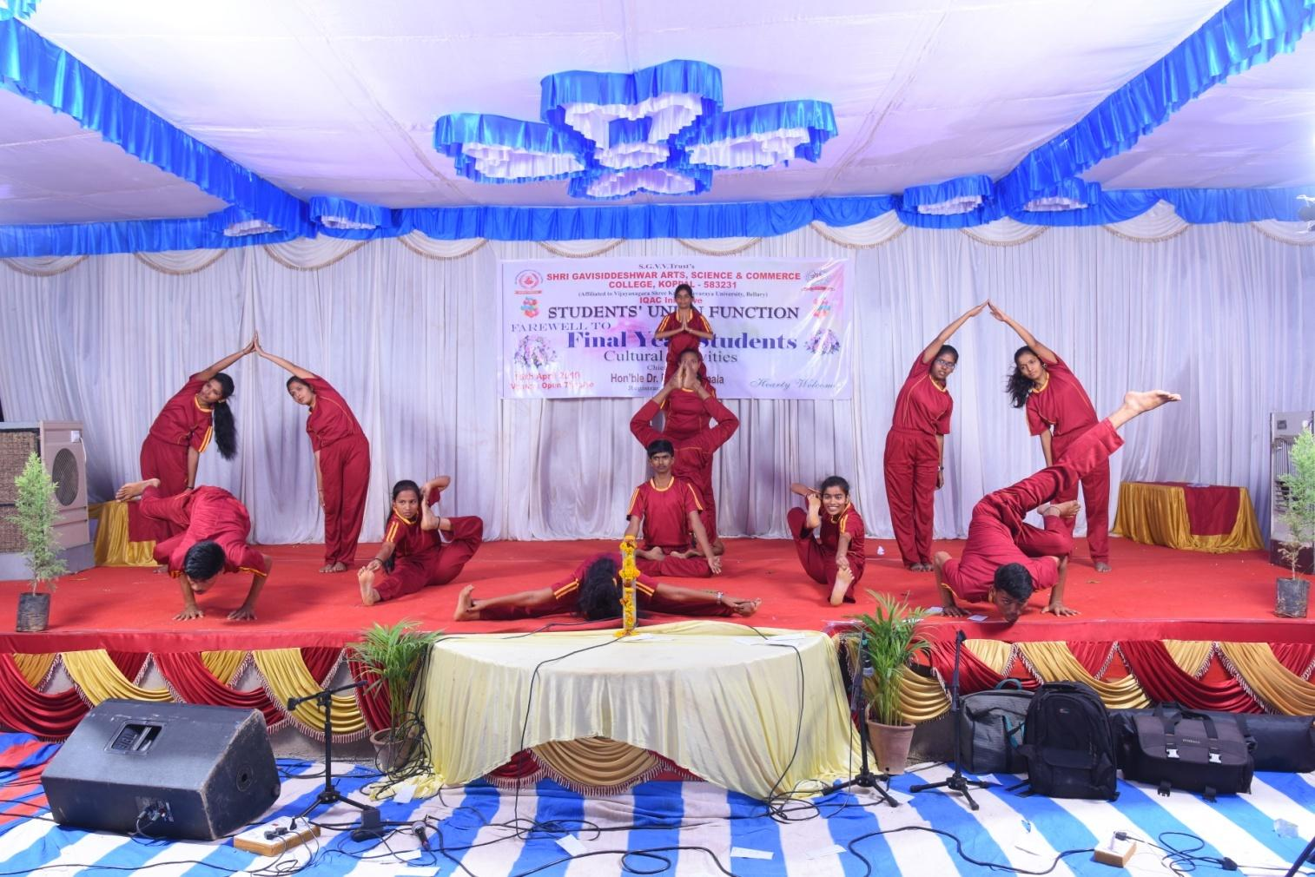

Annual Sports Prize Distribution Ceremony

