Accredited by NAAC ‘B’ Grade | S.G.V.V.T’s  SRI GAVISIDDESHWAR  Arts Science and Commerce College, Koppal  (Affiliated By Vijayanagara Sri Krishnadevaraya University, Ballari)

DEPARTMENT OF PHYSICAL EDUCATION
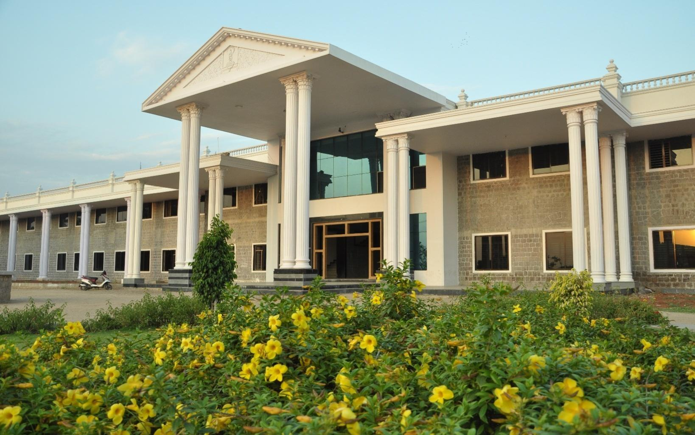

ANNUAL REPORT 2019-20

Contents

- About the Department
- Annual Report
- List Of University Representatives
- Performance in Inter-Collegiate Tournaments.
- Photo Gallery

- About the Department:

I am here to place a brief report of physical education department of our college. This is to bring it to your kind personal that our instructions besides achieving academic excellence due importance has also been given to sports activities. Until the establishment of the physical education department of sports activities were conducted for the students by teaching staff. However to provide systematic education to the students. In the year 1979 a full pledged department of the physical education was established and also appointed a part-time physical director. There after sports activities became part and partial of academic activities.

We are proud to mention here that so for our department has produced more than 209 University Representatives (University Blues) in various in Team games. Sir, we are having our representation in Athletics, Kho-Kho, Volleyball, Cross Country, Wrestling, Judo, Kabaddi, Chess, Handball, Pencak Silat and Power Lifting Weight Lifting in the University teams. Several times our college University Representatives have led the University team effectively participated in Inter-University tournaments held in different states.

Further, to involve more numbers of students in sports, activities, Intra-mural sports activities are conducted every year. Generally in the month of January and February. Annual Sports day is organized to give away the prizes to the winners. To inspire and encourage sportsmen and to facilitate University players. Important personalities in field were invited as chief guest. To mention few Dr.Pratap Singh Tiwari, Director of Physical Education GUG, Sri AnandKatti, Ranaji Cricket player and Miss.Premalata Sureban an International Cyclist were invited as chief Guests for annual Day.
We take the pride to mention that the University has recommended our institution to organize 24th Inter Collegiate Athletic meet on 3rd 4th and 5 December 2004 for which all preparatory and necessary arrangements are going on.

We are thankful to the management of the institution who were kind enough to encourage and scope for the development of sports activities.

- Annual Report:

It is our proud to inform that, the department tried to support the students overall growth and development through organizing various events annually such as Cricket League, Kabaddi league, Volleyball league, Badminton league, Chess , Carom and Athletics at the institutional level, While various students participated in inter-collegiate tournaments and inter-University competitions. Department of Physical Education was produced more than 209 University Representatives (University Blues)from our college most important achievements for the academic year 2018-19 are as follows.

- Miss. HanamavvaSwari and Miss Parvethemmahas participated in the Inter Collegiate Cross-Country Championship held at GFGC Mariyammanahalli on 20th&21stAugust 2019. Both has selected for All India Inter-university Cross Country Championship 2019-20 held at AndraUniversity,Vishakapattanam on 10th October 2020.
- The MenKho-KhoTeam has participated and well performed in the Inter-Collegiate Kho-kho Tournament hel on 12th and 13thSeptember 2019 at P.G Center Nandihalli.
- The Men Volleyball Team has participated and well performed in the Inter-Collegiate Volleyball Tournament held on 17th and 18th September 2019 at S.H.V.F.G.C Kamalapura in this our Mr.ShivakumarHatti selected and Reprsented VSKU Ballari at South-Zone Inter-University Volleyball Tournament held at Krishna University Machalipattanam from 26th to 30th November. The MenKho-KhoTeam has participated and well performed in the Inter-Collegiate Kho-kho Tournament hel on 12th and 13thSeptember 2019 at P.G Center Nandihalli.
- Mr. Praveen has participated and got Silver medal in the Inter-Collegiate Wrestling Championship 2019-20 held on 20th and 21st September 2019 at S.R.M.P.P GFGC Huvinahadagali.
- The Men and Women Chess Team has participated and women team got 3rd Place in theinter-collegiate Chess Tournament an held on 30th Sept and 1st October-2019 in T.M.E.A’sB.Ed College Gangavati.
- The Men and Women Badminton Team has participated and women’s team became Champions in the inter-collegiate Badminton Tournament and held on 3rdto 5th October-2019 in Vijayanagara College Hospete.
- The Men Handball Team has participated and well performed in the Inter-Collegiate Handball Tournament held on 9th and 10thOctober 2019 at S.S.A.G.F.G.C Ballari in this our Mr.ShivakumarHatti, SomuHunagund and Nagaraj.K selected and ReprsentedVSKU Ballari at South-Zone Inter-University Handball Tournament held at Bangaluru North University,Bangaluru from 21st to 24thDecember 2019.
- Mr. Gavichannaveerayya has participated in the Inter Collegiate Cricket Selection Trails on 23rd to 25thOctober 2019 at VSKU Ballari. He has selected and represented VSKU Ballari atSouthZone Inter-University Cricket Tournament held at Mysore University Mysore from 28th November to 15th December-2019.

- TheKarate Men and WomenTeam has participated and well performed in the Inter-Collegiate Karate Tournament held on 30th and 31st October 2019 S.G.R.C.M Govt. Commerce and ManangementCollege,Ballari in this our Miss. Rukmini got 1st place selected and represented VSKU,Ballari at All India Inter-University Karate Championship-2019-20 held at Satyabama University, Chennai from 6th January to 13th January 2020.
- The Yoga Men and Women Team has participated and well performed in the Inter-Collegiate Yoga Selection Trails held on 20th and 21st December 2019 S.G.R.C.M Govt. Commerce and ManangementCollege,Ballari in this our Mr. Ganesh got 1st, Mr. Malleshappa got 3rd place and Miss. Meghana Patil got 3rd Place.The Following are Selected and Represented VSKU ,Ballari at All India Inter-University Yoga Championship 2019-20 held at Rajiv Gandhi University, Nuzvid from 6th to 10th January 2020.
- Mr.GaneshBannad
- Mr.Malleshappa
- Mr.Praveen
- Mr.ManjappaMeti
- Miss.MeghanaPatil
- Miss. RekhaPatil&
- Miss.Megha.

11)Miss. Rukmini and Miss Vaisnavi were participated in the Inter Collegiate Pencak Silat Selection Trails on 27th to 28th December 2019 at GFGC kudalagi. They were selected and represented VSKU Ballari at “All India Inter-University Pencak Silat Championship 2019-20” held at Gulabarga University, Kalaburgi from 21st to 23rd January-2020. In this event our college student Miss. Rukmini bagged Bronze medal in the Ganda Indoor event and this is the 4th Medal in All-India Inter-University from our college history.

Annual Sports Meet was Postponed and Cancelled due to Pandemic Covid-19

- List Of University Representatives:

SL.NO | NAME OF THE ATLETE | CLASS | NAME OF THE COMPETITION |  |  |  |  | REMARKS
01. | MISS. RUKMINI | B.Com-III | ALL INDIA INTER-UNIVERSITY PENCAK SILAT CHAMPIONSHIP 2019-20, GULABARGA UNIVERSITY ,KALABURGI |  |  | BRONZE MEDAL
02. | MISS. VAISNAVI | B.Com-II | -DO-
03. | HANAMAVVA SWARI | BA-II | ALL INDIA INTER-UNIVERSITY CROSS COUNTRY WOMEN CHAMPIOSHIP 2019-20 ANDRA UNIVERSITY, VISHAKAPATTANAM
04. | PARVATHEMMA | BA-I | -DO-
05. | SHIVAKUMAR M.HATTI | B.Com-III | SOUTH ZONE INTER-UNIVERSITY VOLLEYBALL TOURNAMENT 2019-20, KRISHNA UNIVERSITY,MACHALIPATTANAM
06. | GAVICHANNAVEERAYY | B.Com-I | SOUTH ZONE INTER-UNIVERSITY CRICKET TOURNAMENT 2019-20, MYSORE UNIVERSITY,MYSORE
07. | SOMU HUNAGUND | B.Sc-III |  | SOUTH ZONE INTER-UNIVERSITY HANDBALL TOURNAMENT 2019-20, BANGALORE-NORTH UNIVERSITY,BANGALURU
08. | SHIVAKUMARM.HATTI | B.Com-III |  | -DO-
09. | NAGARAJ.K. | B.A-I |  | -DO-
10. | RUKMINI | B.Com-III
11. | GANESH N. | B.Com-III |  | ALLL INDIA INTER-UNIVERSITY YOGA CHAMPIONSHIP-2019-20, RAJIV GANDI UNIVERSITY, NUZIVD, ANDRAPRADESH.
12. | MALLESHAPPA | B.Com-III |  | -DO-
13. | PRAVEEN KUMAR | B.Com-III |  | -DO-
14. | MAJAPPA METI | B.A-II |  | -DO-
15. | MEGHANA PATIL | B.Sc.-III |  | -DO-
16. | REKHA PATIL | B.A.-II |  | -DO-
17. | MEGHA | B.A-I |  | -DO-

4. Performance in Inter-Collegiate Tournaments:
Sl.No | Games And Sports | Year | Place
1. | Cross Country Individual Women | 2019-20 | II
2. | Cross Country Individual Women | 2019-20 | VI
3. | Cross Country Individual Men | 2019-20 | IX
3. | Chess Women Team | 2019-20 | III
4. | Badminton Women Team | 2019-20 | I
5. | Wrestling individual Men | 2019-20 | II
6. | Karate Individual Women | 2019-20 | I
7. | Pencak Silat Individual Women | 2019-20 | I
8. | Pencak Silat Individual Women | 2019-20 | I

5.Photo Gallery

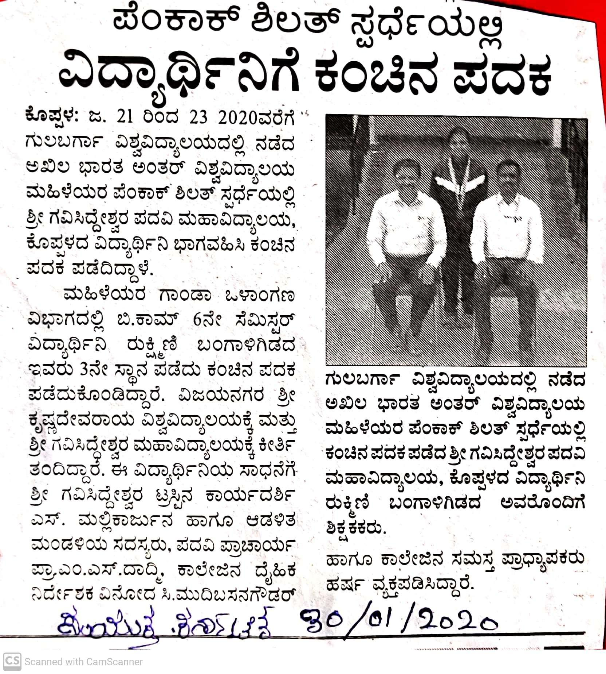

All INDIA INTER-UNIVERSITY PENCAK SILAT CHAMPIONSHIP-2019-20 BRONZE MEDALE, THIS IS THE 4THALL INDIA INTER-UNIVERSITY MEDAL IN THE COLLEGE HISTORY

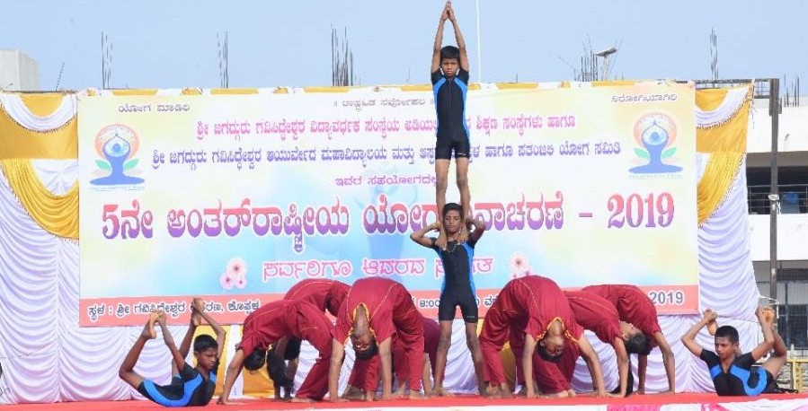
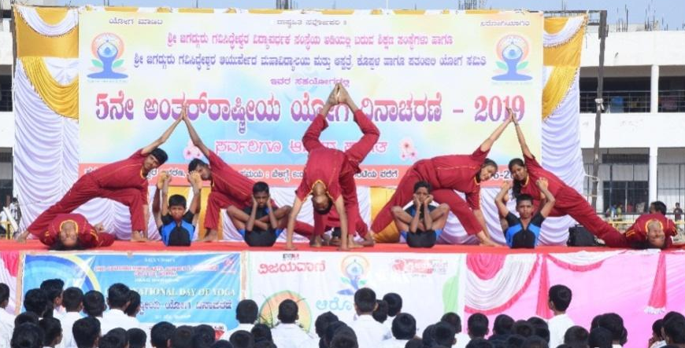
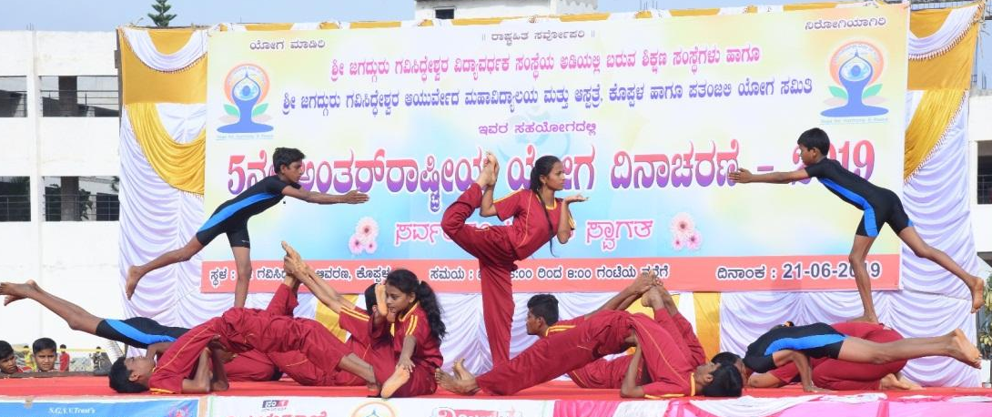
YOGA DANCE PERFORMANCEE ON 5TH INTERNATIONAL DAY OF YOGA
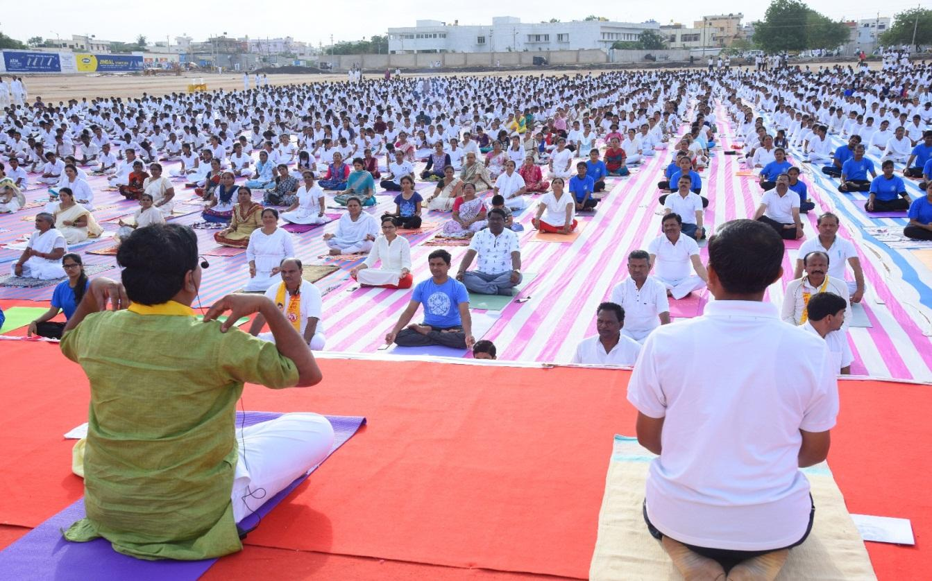
Participation of all students and staff in 5th
International Day of Yoga Organized By
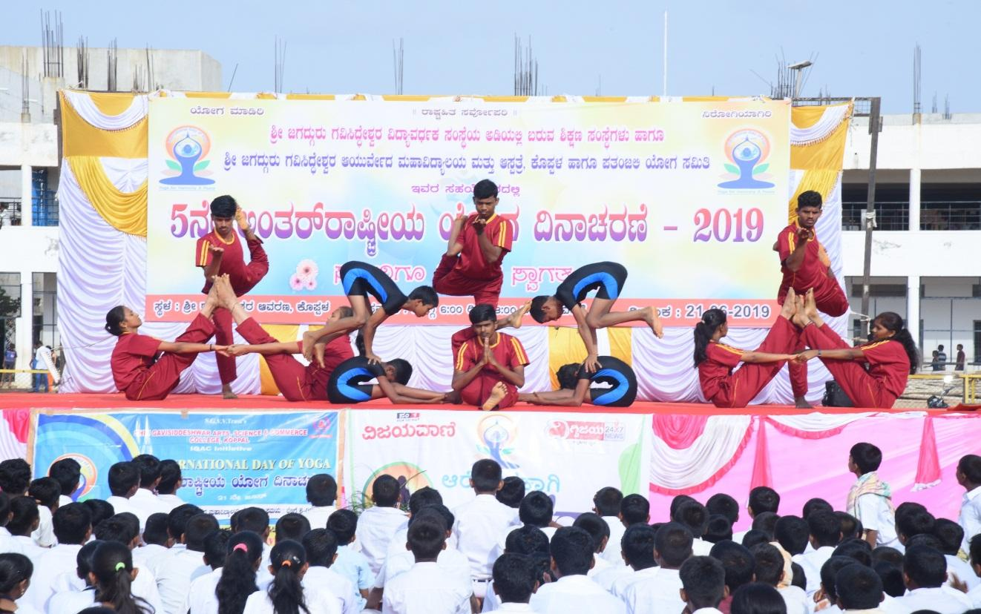

5TH INTERNATION DAY OF YOGA ,DANCE PERFOMANCE BY OUR STUDENTS
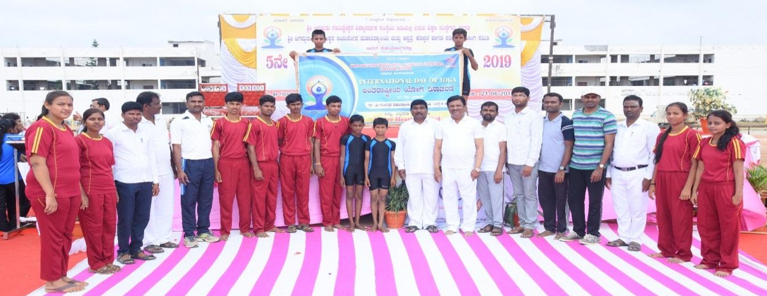
5TH INTERNATIONAL DAY OF YOGA
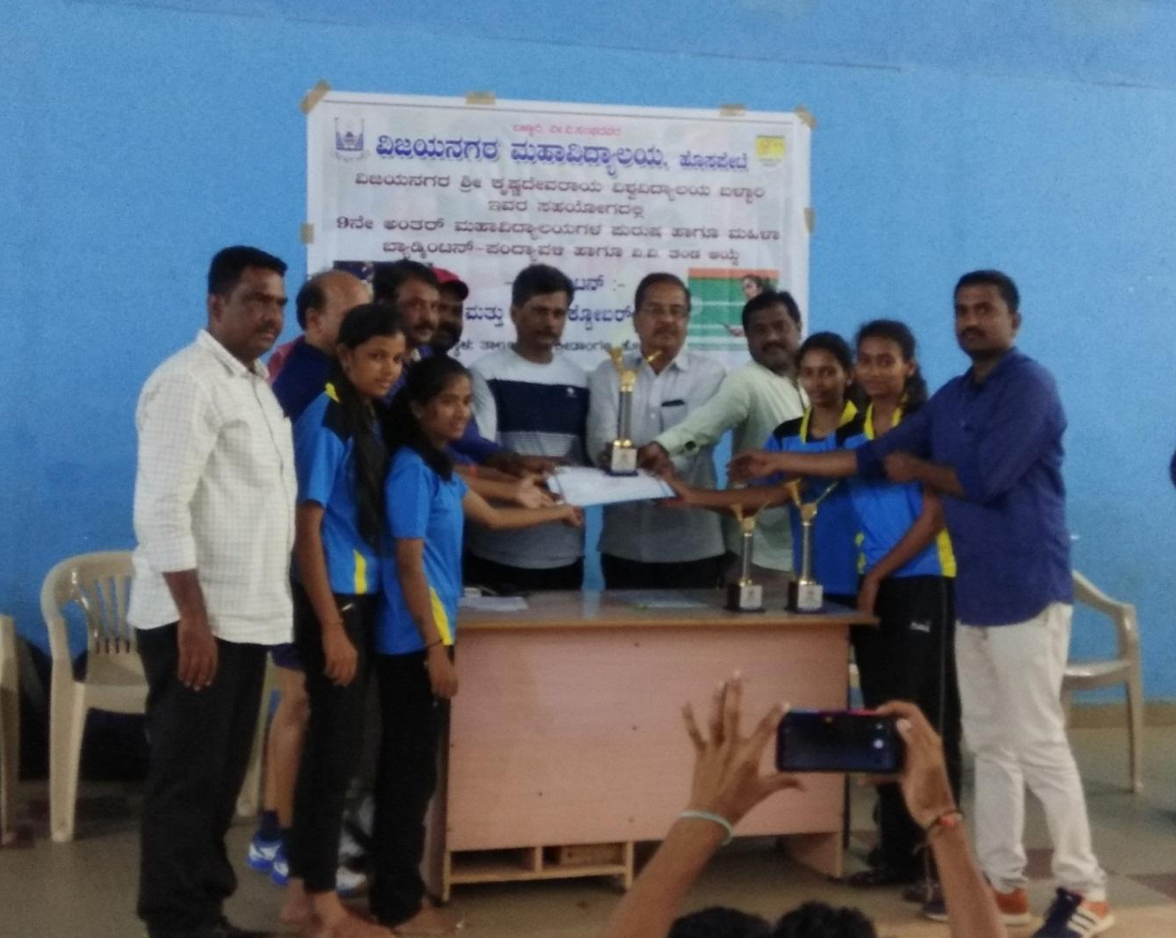
INTER COLLEGIATE BADMINTON WOMEN WINNERS
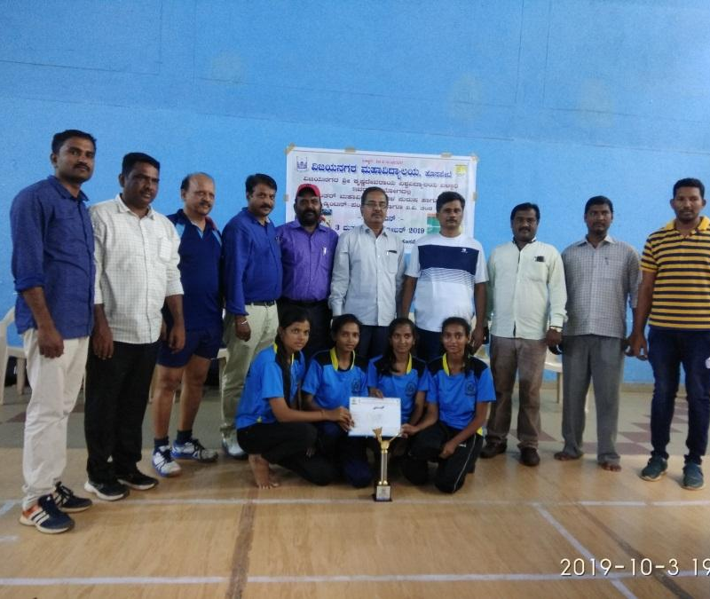
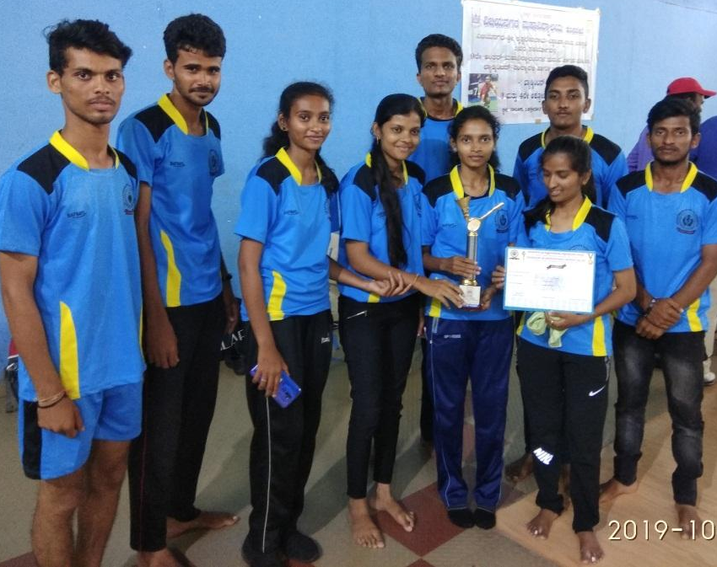
VSKU,Ballari Inter-Collegiate Badminton Championship 2019-20, Vijayanagara College Hospete.
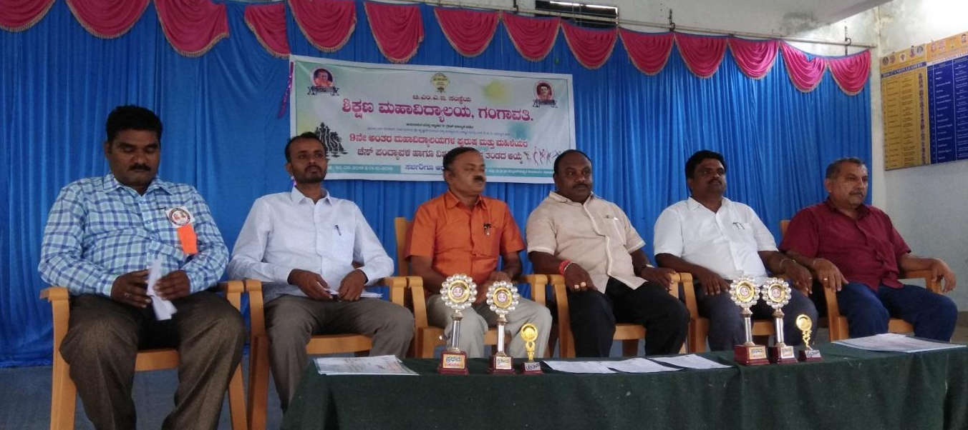
VSKU,BALLARI INTER COLLEGIATE CHESS TOURNAMENT, T.M.E.A’S B.Ed COLLEGE ,GANGAVATI
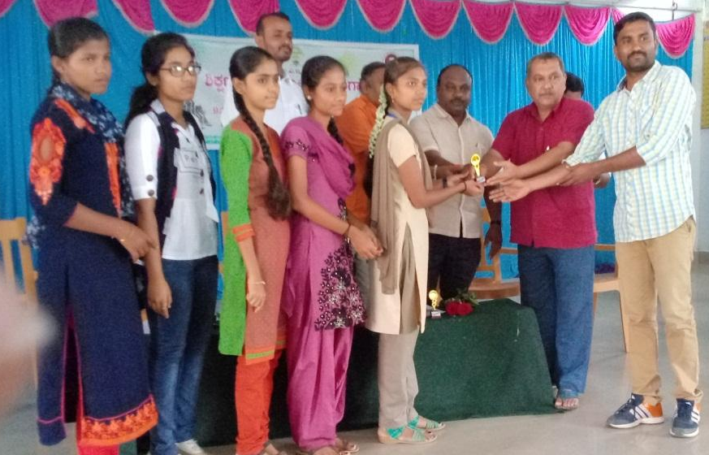

3RD PLACE IN VSKU,BALLARI INTER COLLEGIATE CHESS TOURNAMENT
VSKU,BALLARIINTER COLLEGIATE CROSS COUNTRY CHAMPIONSHIP 2019-20
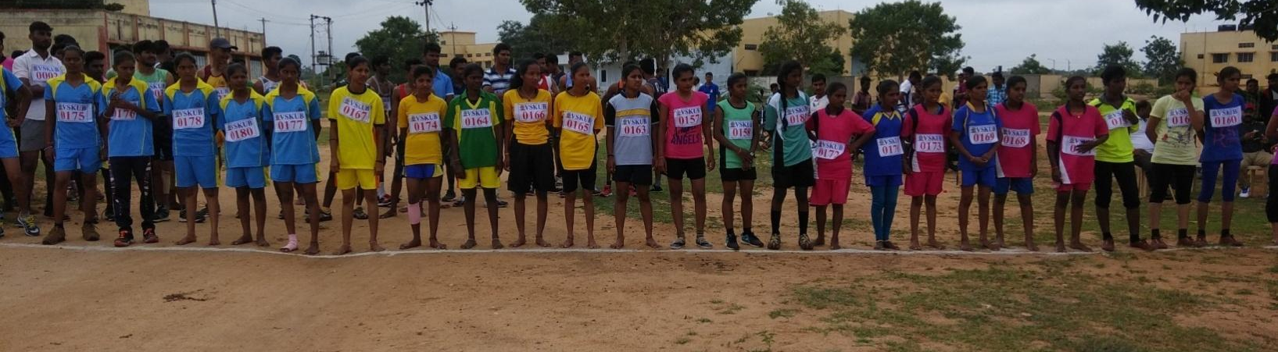
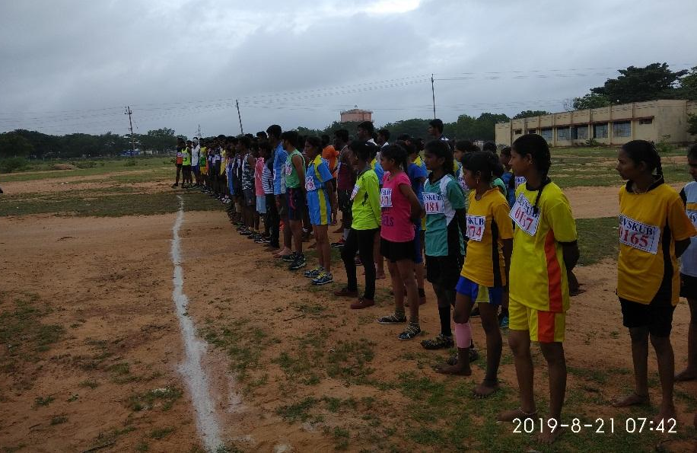

CROSS COUNTRY WOMENS RACE

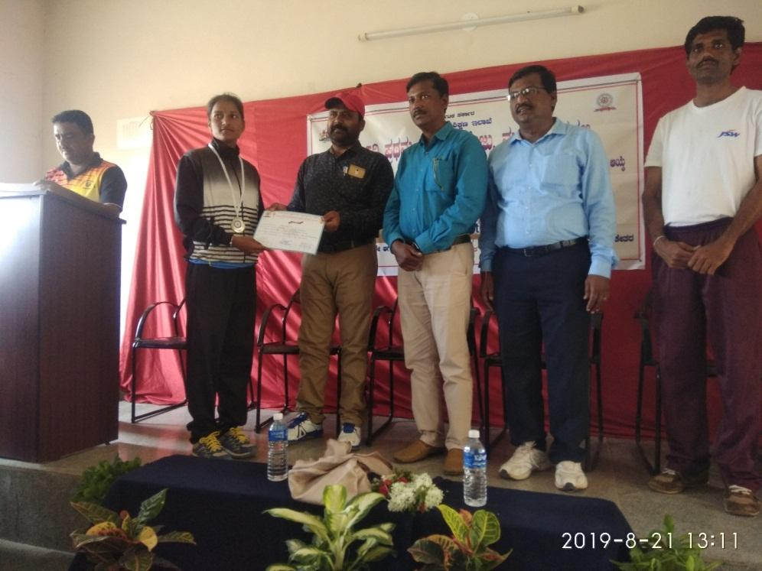

VSKU, BALLARI
INTER COLLEGIATE CROSS COUNTRY CHAMPIONSHIP
2ND PLACE

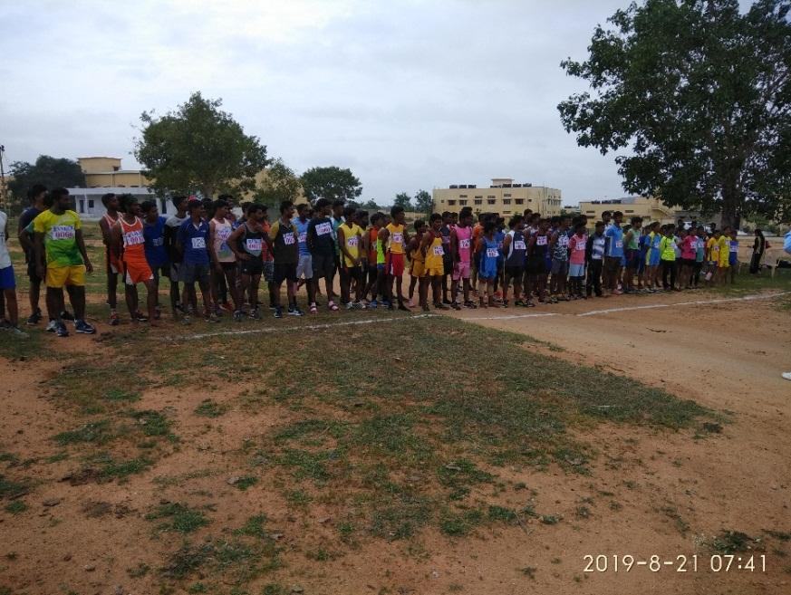

CROSS COUNTRY
MENS RACE

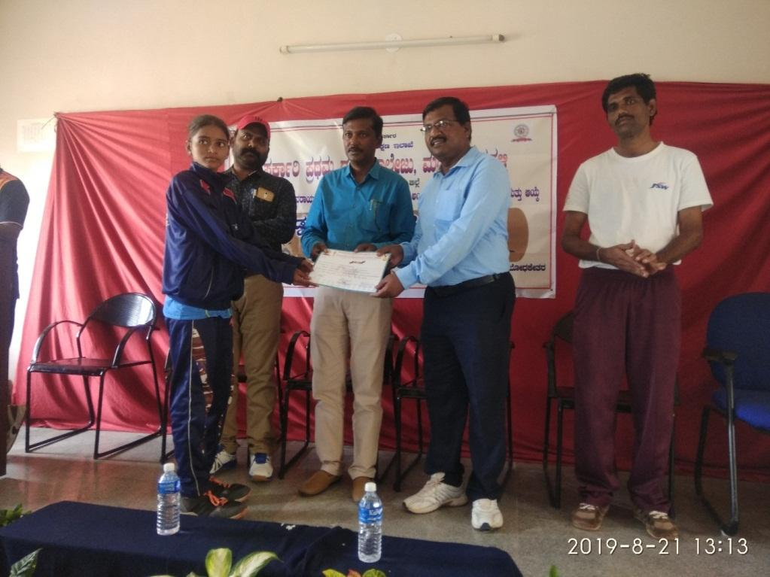

VSKU, BALLARI
INTER COLLEGIATE CROSS COUNTRY CHAMPIONSHIP
6TH PLACE

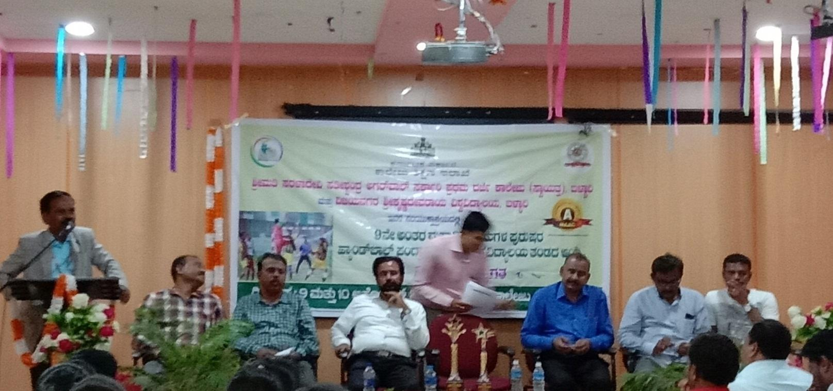
VSKU, BALLARI INTER-COLLEGIATE HANDBALL TOURNAMENT, SSA GFGC BALLARI

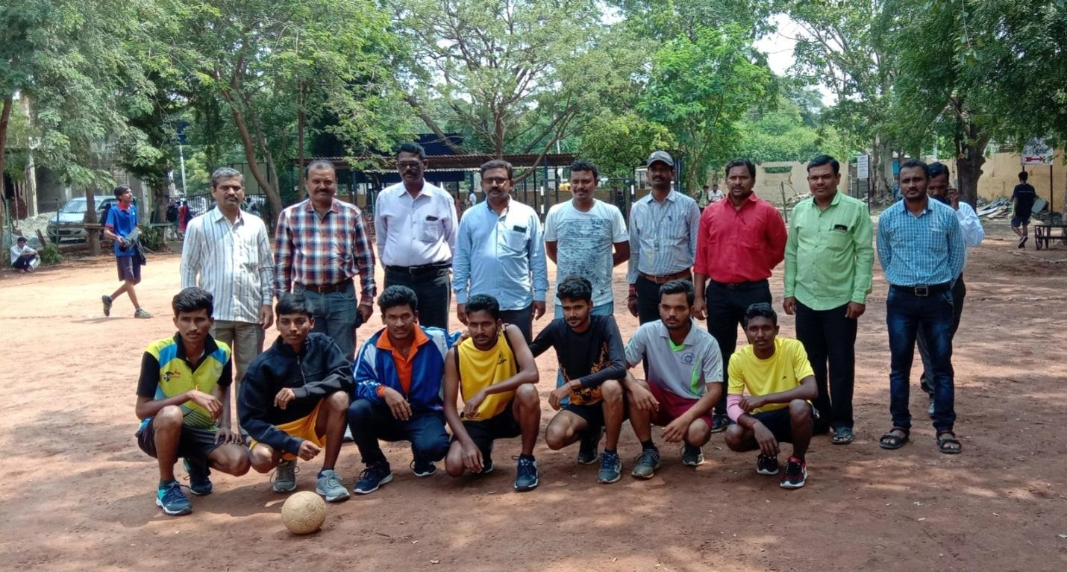

KUMAR SOMU HUNAGUND,KUMAR NAGARAJ OF BA-1ST SEM ,KUMAR SHIVAKUMAR OF B.Com 5TH SEM, SELETED FOR SOUTH ZONE INTER-UNIVERSITY HANDBALL-2019-20
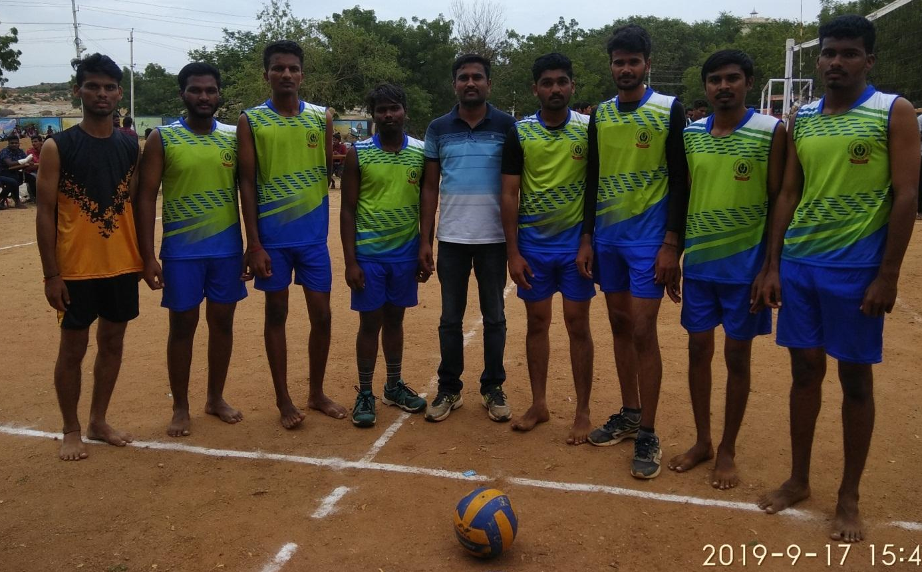
VSKU, BALLARI INTER-COLLEGIATE HANDBALL TOURNAMENT, SSA GFGC BALLARI
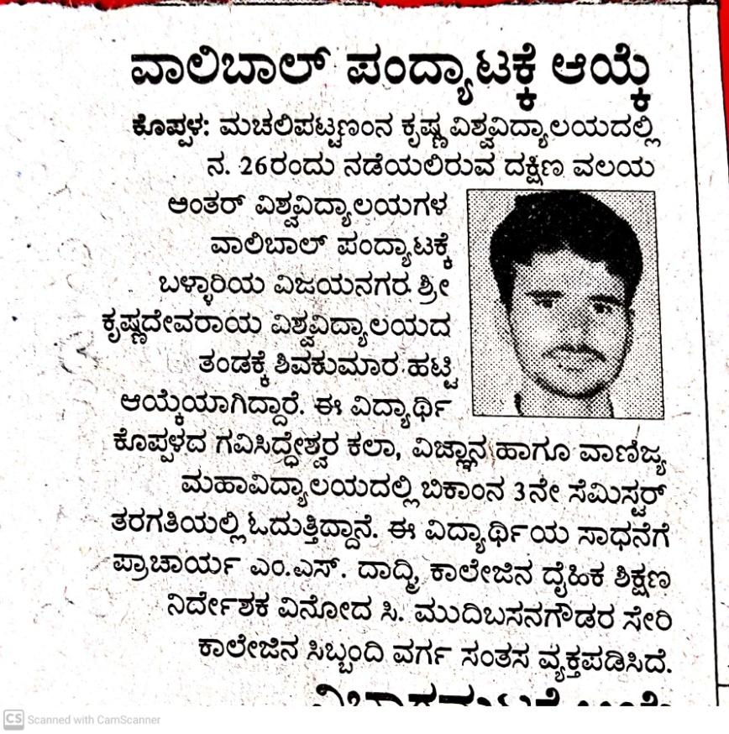

KUMAR SHIVAKUMAR OF B.Com 5TH SEM, SELETED FOR SOUTH ZONE INTER-UNIVERSITY VOLLEYBALL BALL-2019-20

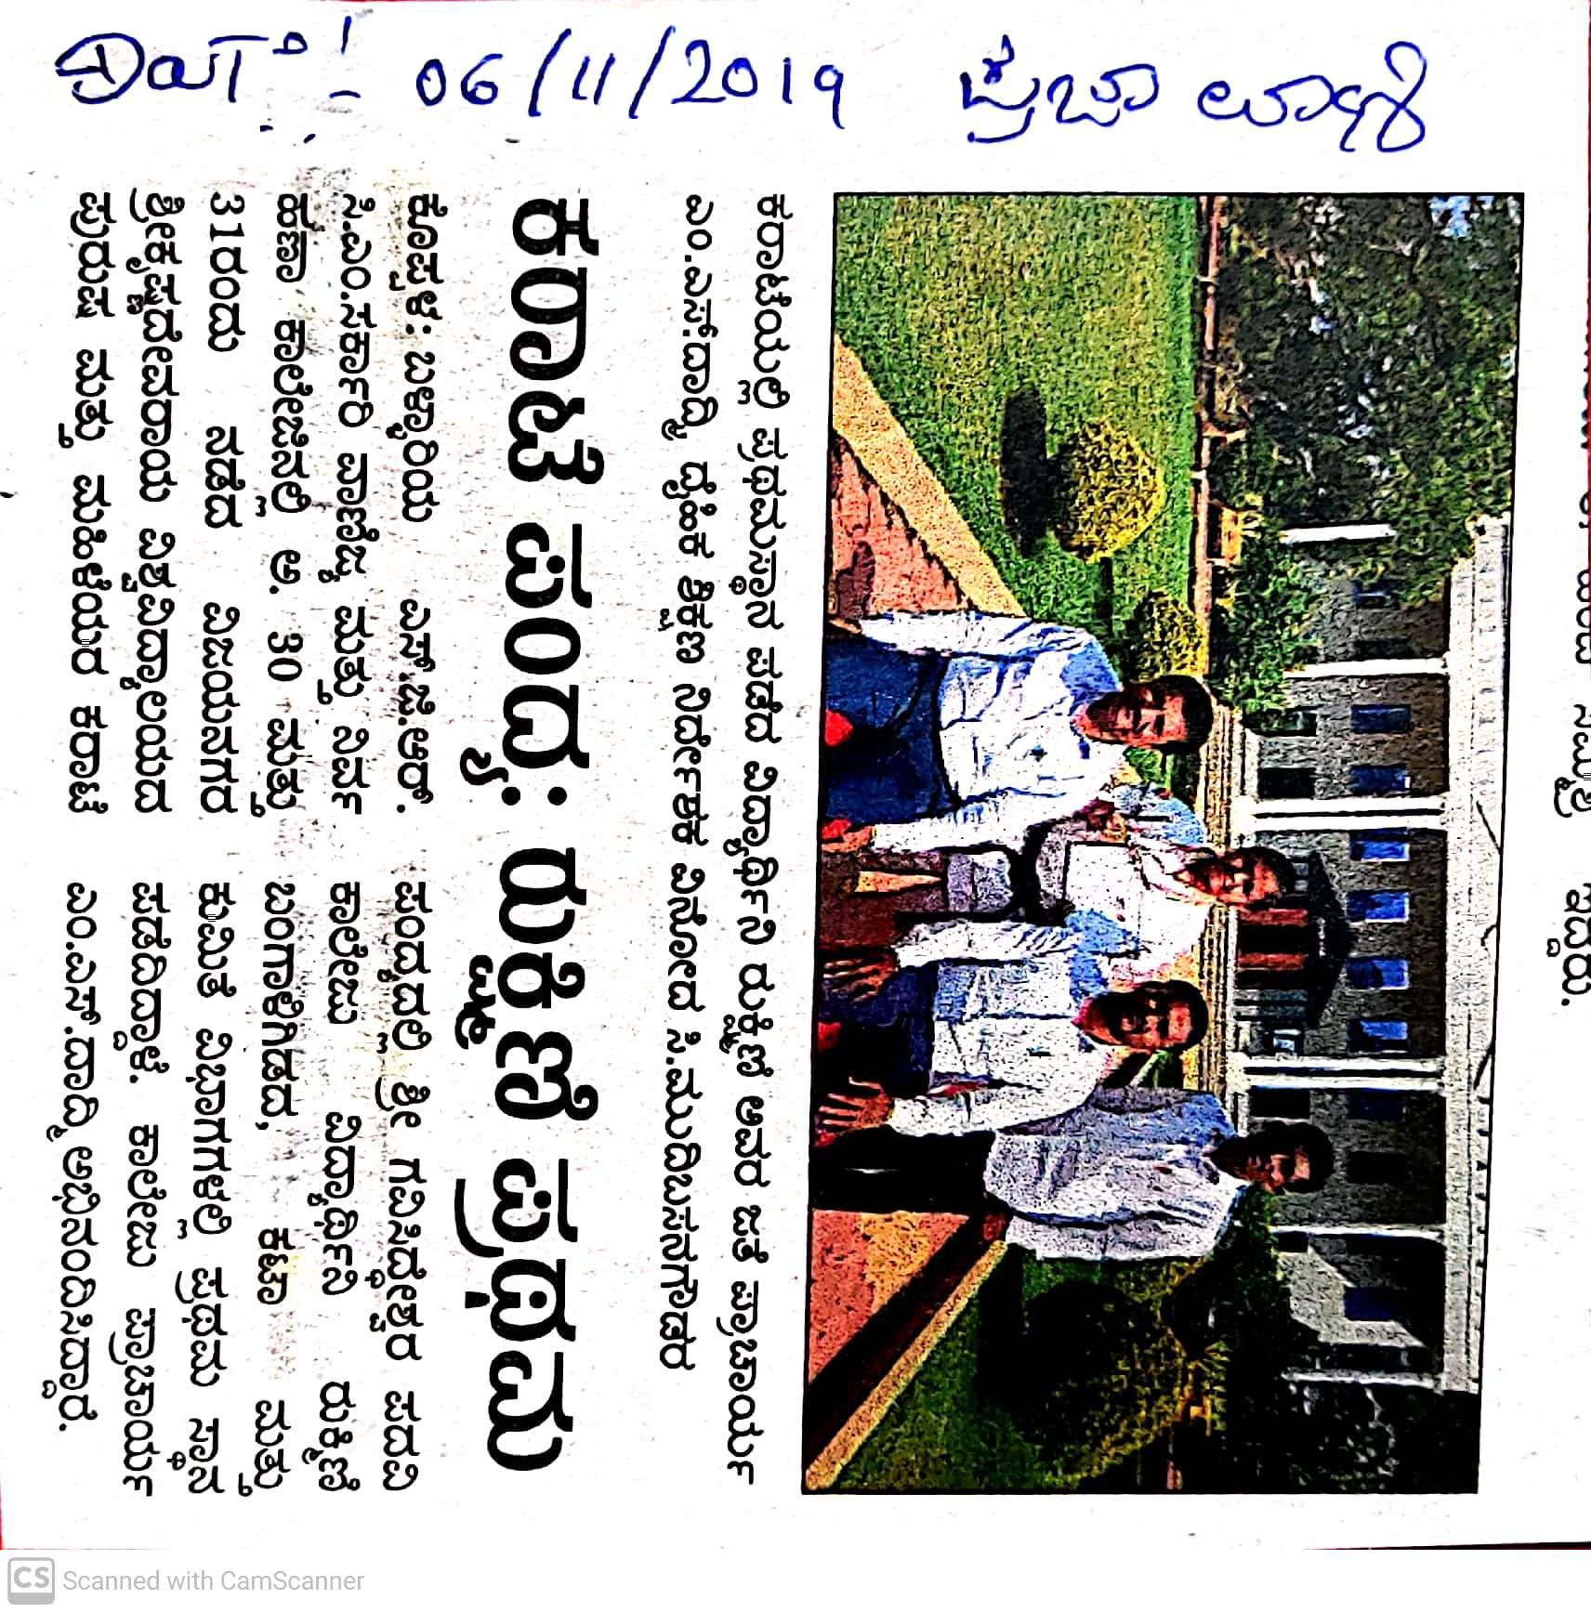

REPRSENTED VSKU, BALLARI KARATE TEAM IN All INDIA INTER-UNIVERSITY KARATE CHAMPIONSHIP-2019-20

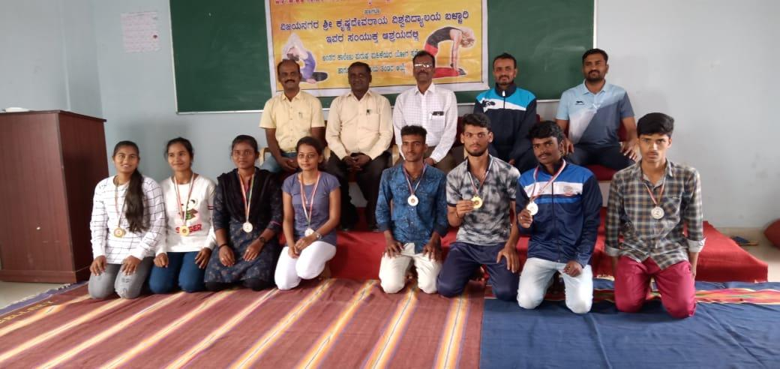

VSKU, BALLARI INTER-COLLEGIATE YOGA COMPETITION 2019-20, S.G.R.C.M GOVT. COMMERCE AND MANAGEMENT COLLEGE, BALLARI,KUMARI.MEGHANA , KUMARI.REKHA AND MEGHA SELECTED FOR ALL INDIA INTER-UNIVERSITY YOGA COMPETITION
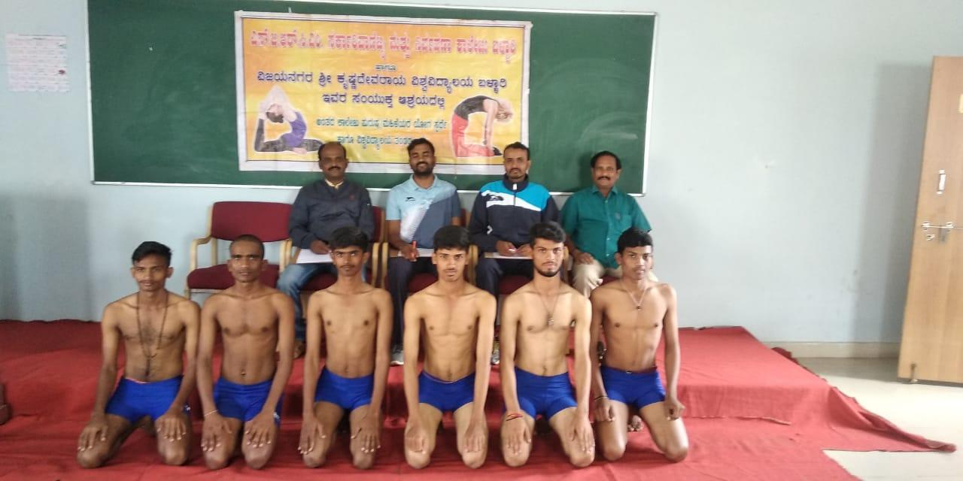
KUMAR.GANESH BANNAD, KUMAR.MALLESHAPPA, KUMAR, PRAVEEN AND KUMAR. MANJAPPA METI SELECTED FOR ALL INDIA INTER-UNIVERSITY YOGA COMPETITION

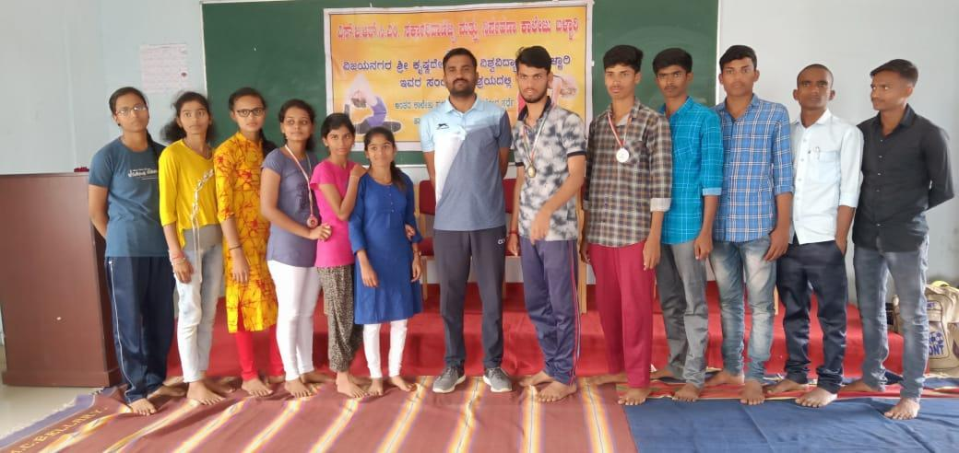
SHRI GAVISIDDESHWAR ART ‘S, SCIENCE ANDE COMMERCRE COLLEGE YOGA MEN & WOMEN TEAM, 2019-20

THANK YOU

