S.G.V.V.T’s
SRI GAVISIDDESHWAR
Arts Science and Commerce College, Koppal
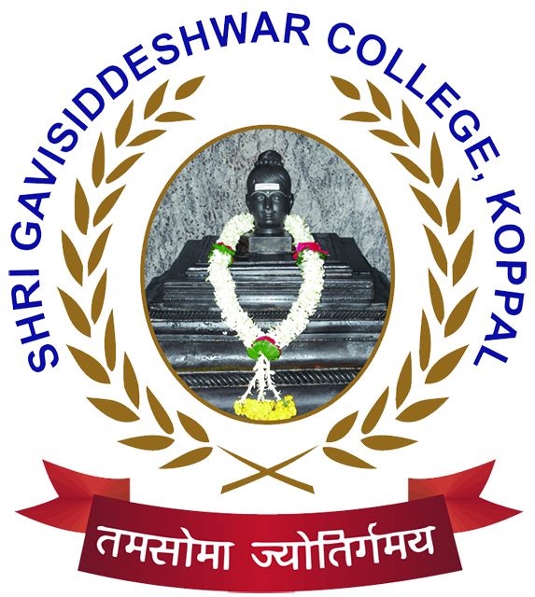
(Affiliated By Vijayanagara Sri Krishnadevaraya University, Ballari)
(Accredited “B++” Grade with CCGA 2.82 by NAAC in 3rd Cycle)

DEPARTMENT OF PHYSICAL EDUCATION
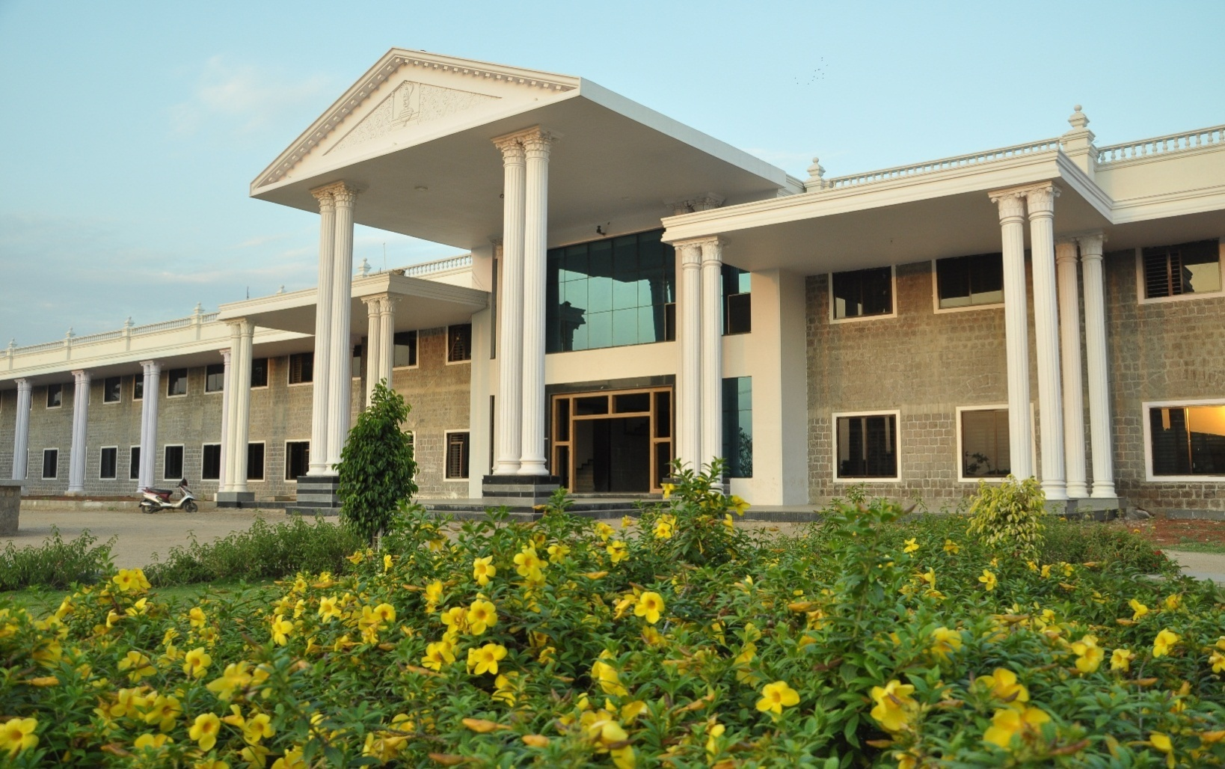

ANNUAL REPORT 2022-23

Contents

- About the Department
- Annual Report
- List of University Representatives
- Performance in Inter-Collegiate Tournaments.
- Inters-Class Tournament Results
- Photo Gallery

- About the Department:

I am here to place a brief report of physical education department of our college. This is to bring it to your kind personal that our instructions besides achieving academic excellence due importance has also been given to sports activities. Until the establishment of the physical education department of sports activities were conducted for the students by teaching staff. However to provide systematic education to the students. In the year 1979 a full pledged department of the physical education was established and also appointed a part-time physical director. There after sports activities became part and partial of academic activities.

We are proud to mention here that so for our department has produced more than 240 University Representatives (University Blues) in various in Team games. Sir, we are having our representation in Athletics, Kho-Kho, Volleyball, Cross Country, Wrestling, Judo, Kabaddi, Chess, Handball, Pencak Silat and Power Lifting Weight Lifting in the University teams. Several times our college University Representatives have led the University team effectively participated in Inter-University tournaments held in different states.

Further, to involve more numbers of students in sports, activities, Intra-mural sports activities are conducted every year. Generally in the month of January and February. Annual Sports day is organized to give away the prizes to the winners. To inspire and encourage sportsmen and to facilitate University players. Important personalities in field were invited as chief guest. To mention few Dr.Pratap Singh Tiwari, Director of Physical Education GUG, Sri AnandKatti, Ranaji Cricket player and Miss.Premalata Sureban an International Cyclist were invited as chief Guests for annual Day.
We take the pride to mention that the University has recommended our institution to organize 24th Inter Collegiate Athletic meet on 3rd 4th and 5 December 2004 for which all preparatory and necessary arrangements are going on.

We are thankful to the management of the institution who were kind enough to encourage and scope for the development of sports activities.

- Annual Report:

It is our proud to inform that, the department tried to support the students overall growth and development through organizing various events annually such as Cricket League, Kabaddi league, Volleyball league, Badminton league, Chess , Carom and Athletics at the institutional level, While various students participated in inter-collegiate tournaments and inter-University competitions. Department of Physical Education was produced more than 240 University Representatives (University Blues) from our college most important achievements for the academic year 2022-23 are as follows.

- Ms Sneha and Ms Basamma of B.Sc II Year has participated and well performed in VSK University Inter-Collegiate Table Tennis Women Tournament and got 2nd place held at VSK University Ballari .These two has selected and represented our university in South Zone Table Tennis Tournament 2022--23 held at Jain University , Bangaluru, Karnataka From 14th to 16th November 2022.

- The Yoga Men and Women Team has participated and well performed in the Inter-Collegiate Yoga Selection Trails held on 15th December 2021 at VSK University Campus, Ballari in this our Mr.Dhanraj 3rd ,Mr.Praveen 6th place and Miss.Soumya got 1st Place,Miss Shilpa got 2nd place ,Akshata got 4th place and Anushri got 5th Plasce. Above are Selected and Represented VSKU ,Ballari in All India Inter-University Yoga Championship 2022-23 held at Kalinga Institute of Social Science University, Buvaneshwar from 26th to 29th December 2022.

- Ms.Ambika participated VSK University Kho-Kho Selection Trails and well performed in the Inter-Collegiate Kho-Kho Tournament our college team got 3rd place at SSA College Ballari and selected and Reprented VSK University in South Zone Inter-University Kho-Kho Tournament Women 2022-23 held at Alliance University Bangalore ,Bengaluru from 21st to 24th November 2022.

- Mr. Manjunath has participated Inter-Collegiate Chess Men Tournament held at VSK University Campus Ballari. He has selected and represented VSK University in South Zone Inter-University Chess Tournament held at S.R.M University, Chennai From 10th to 12th March 2023.

- Ms. Anusree A. K has participated in Inter-College Women’s Badminton Tournament at VSKU, Bellary and our team got second place in that selected and represented our University at South-Zone Inter-University Badminton Tournament from 21-11-2022 to 24-11-2022 held at Jain University, Bengaluru.

- Ms.Sarita, Mr. Shivappa and Mr. Yamanoor have participated in Inter-College Women and Men’s Cross country Tournament at VSKU, Bellary and took 6th ,1st and 6th place respectively ,in that selected and represented our University at All India Inter-University Tournament on 12-02-2023 held at Presidency University, Bengaluru.

- Ms.Nethra has participated in Inter-College Women’s Karate Tournament performed well at VSK University Inter-collegiate Tournament and got First place in that selected and Represented our University at All India Inter-University Karate Tournament from 17-01-2023 to 23-01-2023 held at Atal Bihari Vajpayee University, Chattisgarh.

- Mr. Chetankumar and Mr.Ningajja have participated in Inter-Collegiate Wrestling Men’s Tournament at VSKU, Bellary in that got 1st and 2nd place respectively selected and represented VSK University at South Zone Inter-university University Wrestling Tournament from 21-01-2023 to 29-01-2023 held at Shivaji University Kolhapur, Maharastra.

- Ms. Shridevi, Ms.Aishwarya, Ms. Jyothi, Ms.Sahana and Ms. Saritha and also Mr. Ganesh, Mr. Basavaraj and Mr.Devendra have participated in Inter-College Rope Skipping Tournament at VSKU, Bellari in that selected and represented our University at All India Inter-University Tournament from 21-01-2023 to 24-01-2023 held at Jagannath University, Bhopal, Madhya Pradesh.

- Mr. Shivappa have participated in Inter-College Men’s Athletics Tournament at VSKU, Bellari in that selected and represented VSK University at All India Inter-University Rope Skipping Tournament from 09-01-2023 to 12-01-2023 held at Tamil Nadu Physical Education and Sports University, Chennai, Tamil Nadu.

- Ms. Shweta have participated in Inter-College Women’s Volley Ball Tournament at VSKU, Bellari in that selected and represented VSK University at South-Zone Inter-University Volleyball Tournament from 27-12-2022 to 31-12-2022 held at Mahatma Gandhi University, Kerala.

- Mr. Maruti have participated in Inter-College Men’s Handball Tournament at VSKU, Bellary in that selected and represented VSK University in South-Zone Inter-University Handball Tournament from 04-02-2023 to 08-02-2023held at Periyar University, Tamil Nadu.

- List Of University Representatives:
SL.NO | NAME OF THE ATLETE | CLASS | NAME OF THE COMPETITION |  | Date |  | REMARKS
01. | Akshatha | B.Sc-III | ALL INDIA INTER-UNIVERSITY YOGA TORNAMENT (M&W) HELD AT KIIT UNIVERSITY BUBANESHWAR | 26-12-2022 TO 29-12-2022
02. | Anushree A K | B.Com-III | -Do- | -Do-
03. | Shilpa G K | B.Com-III | -Do- | -Do-
04. | Soumya P | B.Sc-I | -Do- | -Do-
05. | Praveen Hotti | B.A-III | -Do- | -Do-
06. | Dhanaraj | B.Sc-III | -Do- | -Do-
07. | Anushree A K | B.Com-III | South Zone Inter-University Badminton Tournament (W) Held At Jain University, Bengaluru | 21-11-2022 TO 24-11-2022
08. | Sneha | B.Sc-II | South Zone Inter-University Table Tennis Tournament Held At Jain University, Bengaluru | 14-11-2022 TO 16-11-2022
09. | Basamma | B.Sc-II | -Do- | -Do-
10. | Ambika | BA-II | South Zone Inter-University Kho-Kho (W) Tournament Held At Alliance University ,Bengaluru | 22-01-2023 To 26-01-2023
11. | Shwetha | M.Com-II | South Zone Inter-University Volleyball (W) Tournament Held At Mahathma Gandhi University , Kerala
12. | Shivappa | BA-III | All India Inter-University Cross Country Men Competition Held At Presidency University,Bengaluru | 12-02-2023
13. | Yamanoor | BA-II | -Do- | -Do-
14. | Sarita | BA-II | -Do- | -Do-
15. | Shivappa | BA-III | South-West Zone Inter-University Athletics Tournament Held At Tnpes University,Chennai | 09-01-2023 To 12-01-2023
16. | Netra | BA-I | All India Inter-University Karate Women Championship Held At ABVV University,Bilaspur,Chattisgarh | 17-01-2023 To 23-01-2023
17. | Chetankumar | BA-III | All India Inter-University Wrestling Men Tournament Held At Shivaji University , Kolhapur, Maharashtra | 27-01-2023 To 29-01-2023
18. | Ningajja | BA-II | -Do- | -Do-
19. | Devendra E | B.Sc-III | All India Inter-University Rope Skipping Tournament (M&W) Held At Jagannath University,Bhopal,Madhyapradesh | 21-01-2023 To 24-01-2023
20. | Basavaraj | B.Sc-III | -Do- | -Do-
21. | Ganesh | B.Com-III | -Do- | -Do-
22. | Shridevi | B.Sc-III | -Do- | -Do-
23. | Sahana Ganapa | B.Sc-III | -Do- | -Do-
24. | Aishwarya | B.Sc-III | -Do- | -Do-
25. | Jyothi Y | B.Sc-III | -Do- | -Do-
26. | Sarita | BA-III | -Do- | -Do-
27. | Maruthi | B.Com-III | South Zone Inter-University Handball (M) Tournament Held At Periyar University , Tamilnadu | 04-02-2022 To 08-02-2022
28. | Manjunath | B.Sc-III | South Zone Inter-University Chess (M) Tournament Held At Srm University,Kattankulathur, Tamilnadu | 10-03-2023 TO 12-03-2023
- Performance in Inter-Collegiate Tournaments:
Sl.No | Games And Sports | Place | Date | Remarks
1. | Yoga Men | II | 17th & 18th December 2022
2. | Youga Women | I | 17th & 18th December 2022
3. | Table Tennis Women | II | 7th & 8th November 2022
4. | Kho-Kho Women | III | 3rd & 4th January 2023
5. | Chess Women | I | 14th &15th December 2022
6. | Chesss Men | III | 31st December 2022

5. Inter-Class Tournament Results.
Sl.No | Name of the Team/Athlete | Sports & Games | Place | Remarks
1. | Ujwal | Badminton Singles(M) | I
 | Devendra E. | Badminton Singles(M) | II
2. | Anushree A.K | Badminton Singles(W) | I
 | Triveni | Badminton Singles(W) | II
3. | Ujwal&Manoj | Badminton Doubles(M) | I
 | Channaveer & Prakash | Badminton Doubles(W) | II
4. | Triveni & Sindhu | Badminton Doubles(M) | I
 | Anushree A.K & Soumya | Badminton Doubles(W) | II
5. | Praveen & Prashanth | Carom Doubles(M) | I
 | Shridhar & Ajay | Carom Doubles(M) | II
6. | Ranjta & Deepa | Carom Doubles(W) | I
 | Sejal & Ambika | Carom Doubles(W) | II
7. | Pavan | Table Tennis Singles(M) | I
 | Bharat | Table Tennis Singles(M) | II
8. | Priyanka | Table Tennis Singles(W) | I
 | Sindhu C.G | Table Tennis Singles(W) | II
9. | Bharat & Kiran | Table Tennis Doubles(M) | I
 | Basavaraj & Pavan | Table Tennis Doubles(M) | II
10. | Priyank & Sneha | Table Tennis Doubles(W) | I
 | Sindhu & Basamma | Table Tennis Doubles(W) | II
11. | Devendra E. | Chess(M) | I
 | Praveen | Chess(M) | II
12. | Vidyarthi | Chess(W) | I
 | Laxmi | Chess(W) | II
13. | Shuokat Ali and Team | Volleyball(M) | I
 | Yashwanthgouda and Team | Volleyball(M) | II
14. | Anita and Team | Volleyball(W) | I
 | Umadevi and Team | Volleyball(W) | II
15. | Sneha and Team | Throwball(W) | I
 | Parvati and Team | Throwball(W) | II
16 | Niteesh and Team | Kabaddi(M) | I
 | Sameer and Team | Kabaddi(M) | II
17 | Sarita and Team | Kabaddi(W) | I
 | Prema and Team | Kabaddi(W) | II

6. Photo Gallery

Indoor Games Inauguration 25-07-2023

Table Tennis Inaugural 25-07-2023

Inter-Class Volleyball Men 10-08-2023

Inter-Class Volleyball Women10-08-2023

Inter-Class Throwball Women Winners 12-08-2023

Inter-Class Throwball Women Runners 12-08-2023

Inter-Class Kabaddi Women Winners 24-08-2023

Inter-Class Kabaddi Women Runners 24-08-2023

Inter-Class Kabaddi Women Final Match 24-08-2023

THANK YOU

VSK University Inter-Collegiate Badminton (M&W) 2022-23

VSK University Inter-Collegiate Badminton Men Winners 2022-23

VSK University Inter-Collegiate Badminton Women Winners 2022-23
THANK YOU

